Simone Marie (Hildenbrand) Vicknair
December 4, 1934 – January 22, 2022

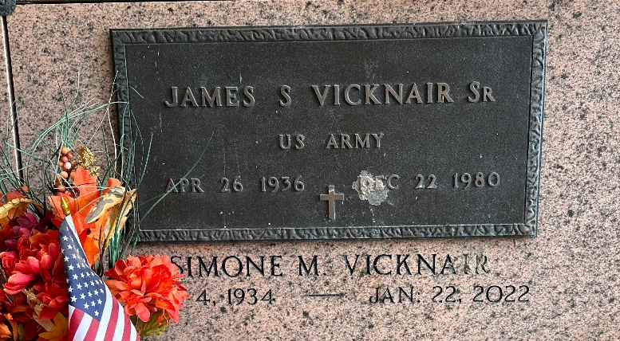
Photo by Team T-Lo

Simone Marie Hildenbrand Vicknair passed away on Saturday, January 22, 2022 at the age of 87. She was a native of Toul, France and a resident of Reserve, Louisiana. Simone was a waitress for 27 ½ years at Airline Motors and was employed with Bakers Heritage for 3 years.
Beloved wife of the late James S. Vicknair, Sr. Loving mother of Pascal Vicknair (Jeanine), James S. Vicknair, Jr. (Dana), Melissa Vicknair Glorioso and the late Cathy Vicknair Gueret (the late, Allen). Grandmother of Vincent Glorioso (Melissa), Michael Glorioso, Dillon Vicknair, Chase Fergunson, Lacey Vicknair, Alicia Vicknair, Tammy Gueret Perret (Kevin) and Cheryl Gueret Vicknair.
Daughter of the late Leon and Marie Louise Batar Hildenbrand. Sister of Suzanne, Pierrette Lecomte, Rene, Hubert, Jean Louis, Claudine, Patrick and the late Mauritius and Bernard. Also survived by many nieces and nephews.
Relatives and friends are invited to attend the Funeral Service on Thursday, January 27, 2022. Visitation will be held at Millet-Guidry Funeral Home, 2806 W. Airline Hwy., LaPlace from 9:30 a.m. until 11:00 a.m. with the Funeral Mass to follow at 11:30 a.m. at St. Peter Catholic Church, 1550 Hwy 44, Reserve. Interment in St. Peter Cemetery, Reserve, LA.
Millet-Guidry Funeral Home, LaPlace, Louisiana
January 25, 2022

