Theodule Ernest Vicknair
August 16, 1872 – July 17, 1945

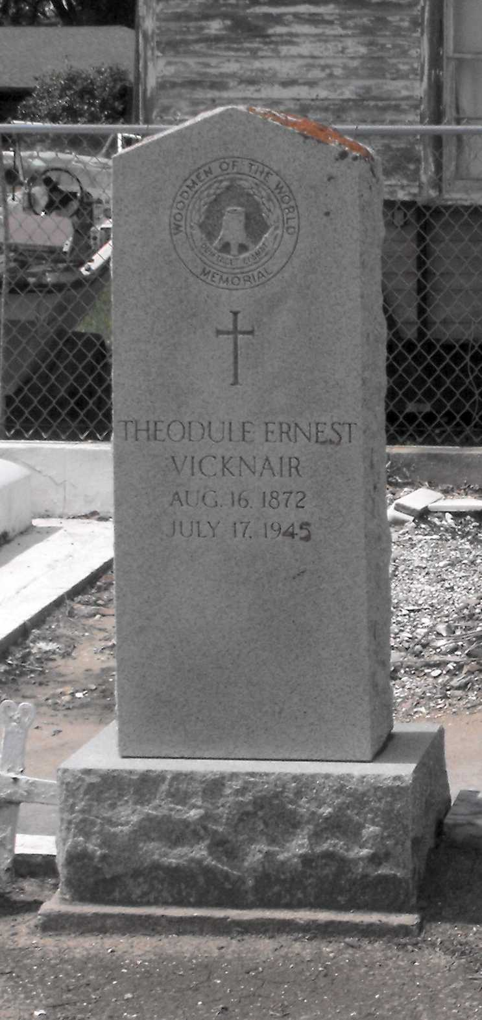
Photo by Mary Agnes Hammett

VICKNAIR - On Tuesday, July 17, 1945, at 2:10 o'clock p.m., ERNEST VICKNAIR, beloved husband of Amanda Jacob, father of Mrs. Ludger Jacob, Mrs. Paul Clement, Mrs. Robert Madere, Mrs. Harry Badeaux and Lolist Vicknair; also survived by 12 grandchildren; aged 72 years 11 months 1 day.

Relatives and friends of the family, also officers and members of the W.O.W. John A Reine Camp No 504, of Laplace, La, employees of the New Southport, are invited to attend the funeral which will take place from the Millet funeral home, Reserve, La. on Wednesday, July 18, 1945, at 4:30 o'clock p.m., followed by religious services at St Peter's church, Reserve, La. Interment in St Peter's cemetery, Reserve, La.
The Times-Picayune, New Orleans, Louisiana
18 Jul 1945, p. 2

