Thomas M. Vicknair
August 26, 1942 – December 31, 2003

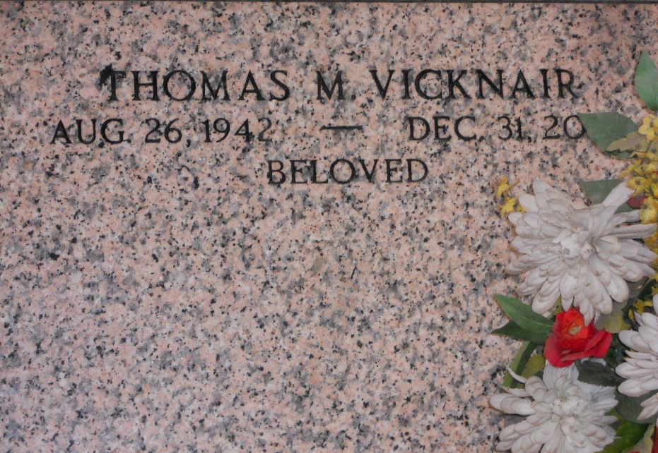
Photo by Team T-Lo

LaPlace - Thomas M. Vicknair, 61, died Wednesday, Dec. 31, 2003.
He is survived by his wife, Lou Anne Vicknair; one son, Alvin "Chip" Vicknair; one daughter, Sharon Freeman; his mother, Freida Vicknair; and three grandchildren.
He was preceded in death by his father, Alvin Vicknair.
Visitation will be today from 5 to 9 p.m. at Millet-Guidry Funeral Home, LaPlace, and Saturday from 8 until 9:45 a.m. The funeral will be held at 10 a.m. at St. Joan of Arc Catholic Church, LaPlace. Burial will be in St. Peter Cemetery, Reserve.
The Daily Star, Hammond, Louisiana
January 2, 2004

