Wallace Armand Vicknair
November 15, 1894 – November 20, 1951

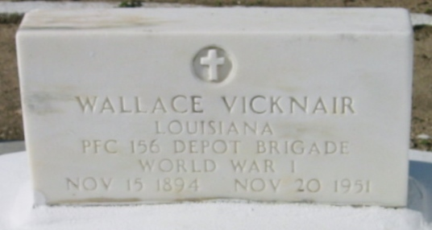
Photo by Bobby

VICKNAIR - On Tuesday, November 20, 1951, at 6:45 o'clock p.m., WALLACE VICKNAIR, beloved husband of Elvina Brou; father of Mrs. Armand Duhe, Mrs. Felix Millet, Whitney, Wallace Jr, Roy and Lesley Vicknair, also survived by six grandchildren, aged 57 years.

Relatives and friends of the family are respectfully invited to attend the funeral which will take place from Millet Funeral Home, Reserve, La. on Thursday, November 22, 1951, at 8:30 o'clock a.m., followed by mass at St Joan of Arc church, Laplace, La, at 9 o'clock. Interment in St Peter's cemetery, Reserve, La.
The Times-Picayune, New Orleans, Louisiana
22 Nov 1951, p. 3

