Wallace Joseph Vicknair Sr.
February 20, 1894 – November 13, 1974

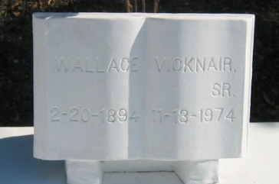
Photo by Bobby

VICKNAIR – Wallace J. Vicknair, Sr., of Garyville, La., on Wednesday, November 13, 1974, at 5:05 o’clock a.m.
Husband of the late Lelia Hymel Vicknair, father of Mrs. Manuel (Odile) Duhon and Mrs. Casper (Elta Mae) Fisher, both of New Orleans, Earl Vicknair of Algiers, Wallace J. Vicknair, Jr., of Arlington, Texas, and the late Percy Vicknair. Brother of Albert Vicknair of Alexandria, La., Mrs. Dewey Weber and Mrs. Martine Weber, both of Reserve, La.; Mrs. Edna Weber of New Orleans, and the late Mrs. Marie Madere, Mrs. Odile Millet, Achille and Felix Vicknair. Also survived by 13 grandchildren and 5 great-grandchildren. Age 80 years. A native of Reserve and a resident of Garyville, La.
Relatives and friends of the family, also U.S. Dept of Agriculture, Continental Can Co., and Schwegmann Brothers, are invited to attend the funeral. Services from Millet Funeral Home, Reserve, La., on Friday, November 15, 1974, at 10 o’clock a.m. Religious services at St. Hubert Catholic Church, Garyville, at 10:30 a.m. Interment St. Peter Cemetery, Reserve, La. Friends may call from 4:30 p.m. to 11 p.m. on Thursday and from 8 a.m. until services on Friday

The Times-Picayune, New Orleans, Louisiana
Thursday, November 14, 1974, section 1, p. 15

