Walter Joseph Vicknair
August 24, 1910 – November 9, 1973

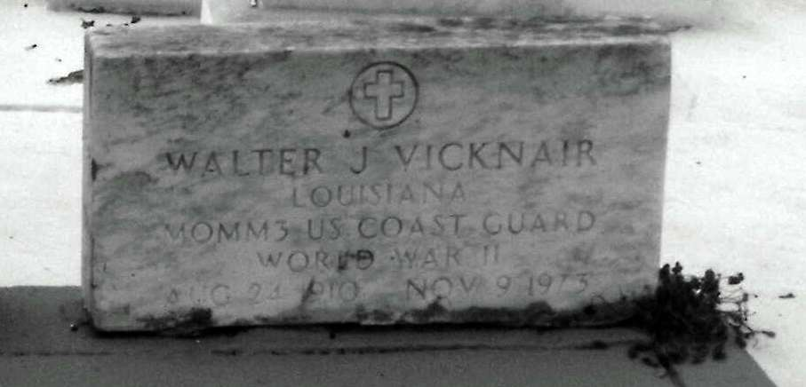
Photo by Mary Agnes Hammett

Walter J. Vicknair of LaPlace, La, on Friday, November 9, 1973, at 5:20 o'clock p.m.; son of Laura Vicknair and the late Marcelin Vicknair; brother of Mrs. Paul (Rita) Giangrosso and Mrs. Lucille Vicknair, both of New Orleans, La; also survived by 1 niece, Mrs. James (Edwina) McCready of Metairie, La; age 63 years; a native and a resident of LaPlace, La.

Relatives and friends of the family are invited to attend the funeral. Services from Millet Funeral Home, LaPlace, La, on Monday, November 12, 1973, at 10 o'clock a.m., followed by religious services at St. Joan of Arc Catholic Church. Interment in St. Peter Cemetery, Reserve, La.

The Times-Picayune, New Orleans, Louisiana
Thursday, November 11, 1973, p. 16

