Wilfred Joseph Vicknair
August 19, 1900 – April 13, 1972

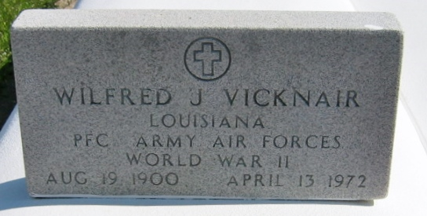
Photo by Bobby

VICKNAIR - Wilfred Joseph Vicknair of Laplace, La, on Thursday, April 13, 1972, at 11:10 o'clock a.m., son of the late Felix Vicknair and Adele Picou. Age 71 years, a native and a resident of Laplace, La.

Relatives and friends of the family are invited to attend the funeral. Services from Millet Funeral Home, Laplace, La, on Saturday, April 15, 1972, at 10 o'clock a.m. Religious services at St. Joan of Arc Church, Laplace, La. Interment in St. Peter Cemetery, Reserve, La.

The Times-Picayune, New Orleans, Louisiana
April 14, 1972, p. 20

