William Vicknair
November 9, 1890 – August 9, 1965

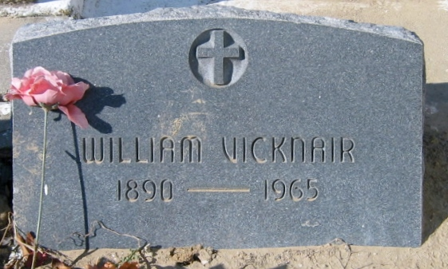
Photo by Bobby

Age 75 years, a native and resident of Reserve, Louisiana.

Husband of the late Inez Elfer and father of Mrs. Irving A. Millet, and Mrs. Leon Klibert, Roy J. Vicknair of Reserve, and Nemour J. Vicknair of Groves, Texas. Brother of Felicien Vicknair of Reserve.

Services were Thursday, 12 Aug 1965, at St. Peter Church, Reserve, with interment in St. Peter Cemetery.

Unknown source

