James Henry Vilemont
December 16, 1878 – May 27, 1916

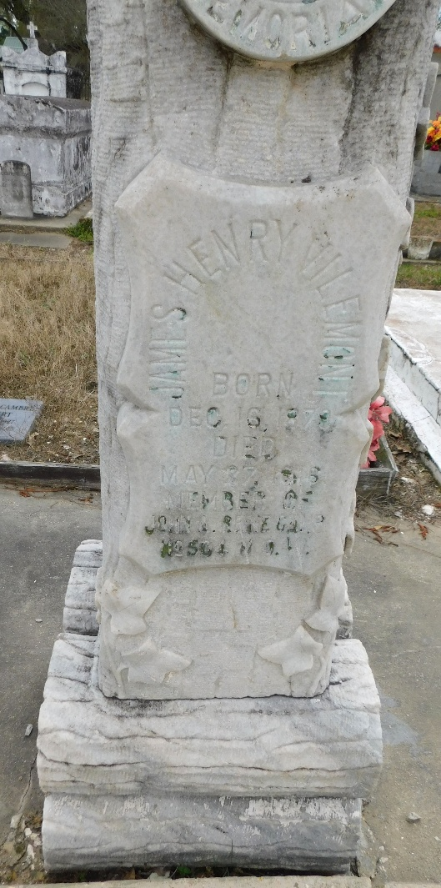
Photo by Mary Agnes Hammett

James Henry Vilemont died Saturday, 27 May 1916, at age 37 years, 5 months and 11 days.

Relatives, friends and Woodmen of the World are invited to attend the funeral services on Monday, 28 May 1916 at St. Peter Church, Reserve, Louisiana. Interment in St Peter Cemetery.

The Times-Picayune, New Orleans, Louisiana
May 28, 1916

