Jules Vilemont
January 3, 1843 – March 6, 1920

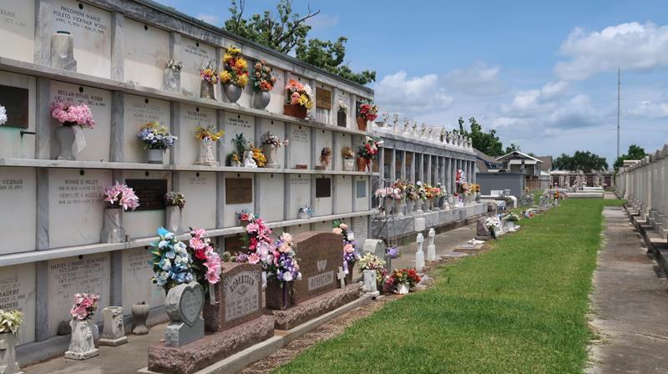

Jules Vilemont, son of Louis Villemont and Scholastique Leche, was born in St John the Baptist Parish, Louisiana, on 3 Jan 1843. He was a farmer. He was the husband of Winnie Ringwood and they were the parents of ten known children.
He enlisted in the Confederate Army at Camp Moore, Louisiana, on 5 Oct 1861. He served in Company A, 18th Regimant, LA Infantry. He was captured and taken prisoner on 14 Apr 1863 at Bayou Teche. He was held in Algiers, Louisiana, where he took the oath of allegiance to United States, as he states, to save his life as he was sick.
He applied for a war pension on 20 Nov 1919. Sheriff William Hart of St John the Baptist Parish in a letter of 22 Nov 1919 wrote to the pension board informing them that Jules was in poor health, almost blind and walking with difficulty, and is unable to earn a living. How-ever, his pension application was denied because he took the oath to the United States.
Jules Vilemont died at Laplace, Louisiana, on Saturday, 6 Mar 1920, at the age of 77 years. Funeral services were held at St Peter Church in Reserve, Louisiana, on Sunday 7 Mar 1920, with interment in St Peter Cemetery.

**
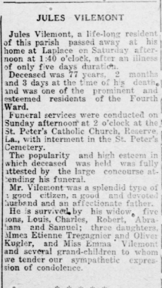

Le Meschacebe, Lucy, Louisiana
March 20, 1920

