Emma Villemont
August 8, 1883 – January 11, 1975

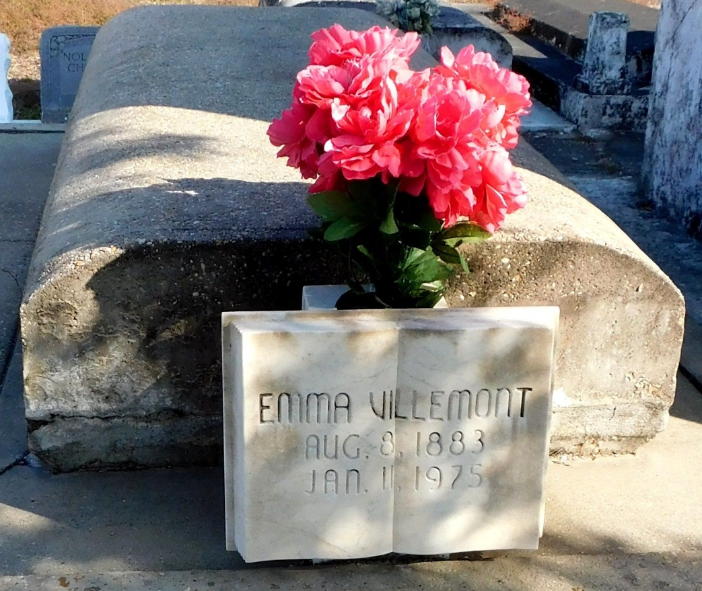
Photo by Mary Agnes Hammett

Emma Villemont, a native and resident of Laplace, Louisiana, died Saturday, 11 Jan 1975, at 11:35 pm at age 91 years.

She was the daughter of the late Winefred Ringwood and Jules Villemont and the sister of Mrs. Nellie Trepagnier and Samuel Villemont of Laplace and the late Louis, Charles, Abraham, Henry, Robert Villemont and Mrs. Marie Kugler.

Services were Monday, 13 Jan 1975, at St Joan of Arc Catholic Church, Laplace, with interment in St Peter Cemetery, Reserve, Louisiana.

The Times-Picayune, New Orleans, Louisiana
January 13, 1975

