Mable Marie (Mabile) Villemont
May 1, 1920 – October 13, 1980

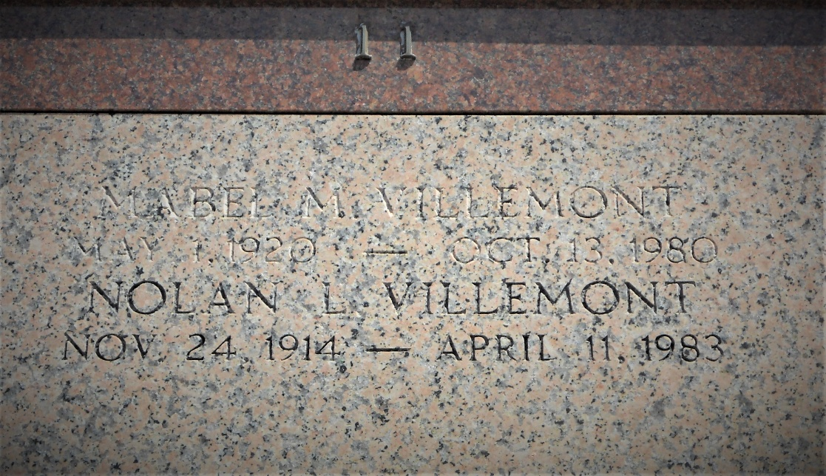
Photo by Team T-Lo

Mabel M. Villemont, a native of Bayou Goula, Louisiana, and a resident of Laplace, Louisiana, for the past 50 years died Monday, 13 Oct 1980 at 5:30 pm at age 50 years.

She was the wife of Nolan Villemont and the mother of Allen Villemont. Also survived by one grandchild. She was the sister of Mrs. Jules (Leona) Edler, Mrs. Pershing (Rita) Catoire, Alexander and Morris Mabile, and the late Holand, Elphage, Albert, Octave, Alvin and John Mabile.

Services were Wednesday, 15 Oct 1980 at St. Joan of Arc Church, Laplace, with interment in St. Peter Cemetery, Reserve, Louisiana.

The Times-Picayune, New Orleans, Louisiana
October 15, 1980

