Nolan Louis Villemont
November 24, 1914 – April 11, 1983

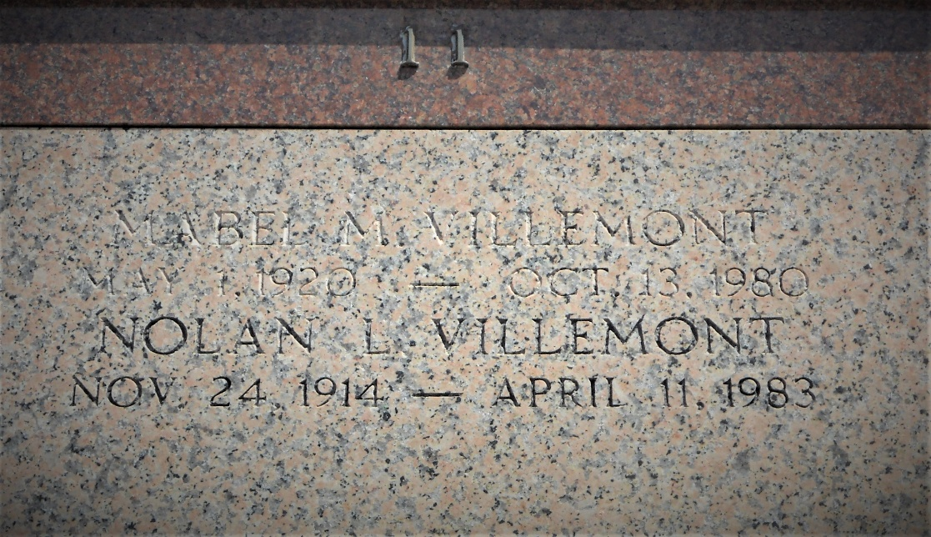
Photo by Team T-Lo

Nolan L. Villemont, a native and resident of Laplace, Louisiana, died Monday, 11 Apr 1983 at 2:30 pm at age 67 years.

He was the husband of the late Mabel Villemont, father of Allen Villemont and father-in-law of Gloria Villemont. Also survived by one grandchild. He was the brother of Alvin Villemont, Louise Reine, Coleen Mancuso, Bernice Edwards and Elaine Tamplain and the late Chester, George and Jules Villemont.

Services were Thursday, 14 Apr 1983 at St. Joan of Arc Church, Laplace, with interment in St. Peter Cemetery, Reserve, Louisiana.

The Times-Picayune, New Orleans, Louisiana
April 13, 1983

