Alvin Joseph Villeret Jr.
December 3, 1953 – March 24, 2021

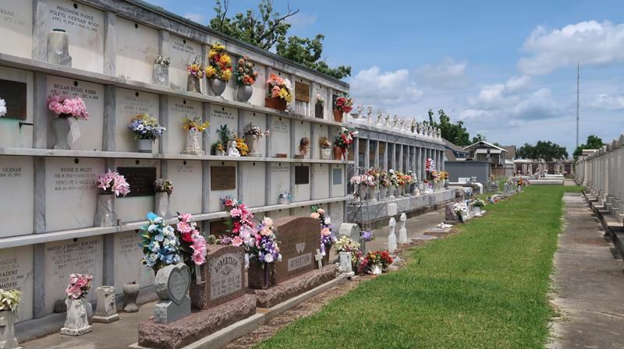

Alvin “Big Al” Villeret, Jr. passed away peacefully at his home surrounded by family on Wednesday, March 24, 2021 at the age of 67. He was born in Vacherie, LA and resided in Reserve, LA. He was happy to be a Mason for 33 years and his home was Progressive Lodge #262. He was known for cooking Jambalaya for any function, such as the Andouille Festival, Charities and West St. John football games for most of his life.
Beloved husband of Janel Scioneaux Villeret. Loving father of Jared Villeret. Son of the late Marilyn Cortez Villeret and Alvin Villeret, Sr. Brother of Michael Villeret (Kitty) and the late Timothy Villeret (Tammy). Son-in-law of the late Edwin “Shot” Scioneaux and Betty LeBlanc Scioneaux. Brother-in-law of Adeline Scioneaux, Kay Kay Scioneaux LeBlanc (Lee) and Perry Scioneaux (Kim). Also survived by his loyal canine companion, “Tippie” and his many godchildren, nieces, nephews, family and friends.
Relatives and friends are invited to attend the Memorial Service at Millet-Guidry Funeral Home, 2806 W. Airline Hwy, LaPlace, LA on Sunday, March 28, 2021. Visitation will be held from 6:00 p.m. to 8:00 p.m. with the Service to immediately follow at 8:00 p.m.

L’Observateur, LaPlace, Louisiana
March 25, 2021

