Timothy Peter Villeret
March 14, 1961 – April 8, 2018

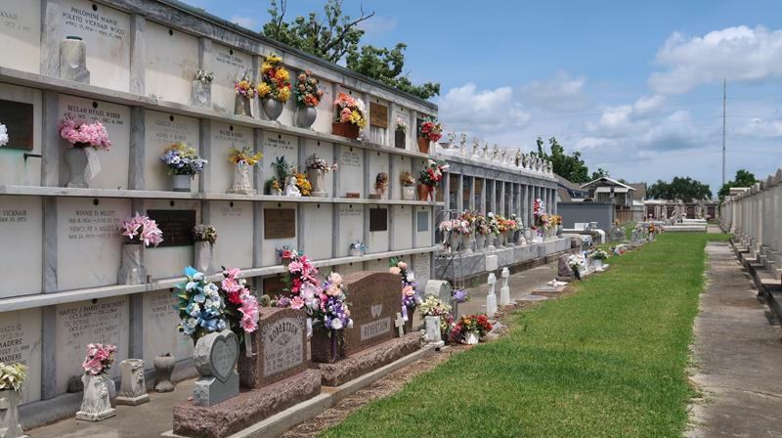

Timothy Peter Villeret “Timmy” passed away on Sunday, April 8, 2018 by the side of his beloved wife and children. He was born on March 14, 1961 in Reserve, LA to the late Alvin “Yellow” Villeret, Sr., and Marilyn Cortez Villeret.
Timmy is preceded in death by his first wife Cara Berthelot Villeret and survived by his wife Tammy Klieve Villeret. He is also survived by his brothers, Alvin Joseph Villeret, Jr. (Janel Villeret) and Michael Villeret (Kitty Villeret).
He has three children: Chase T. Villeret (Anna Wanko Villeret), Marcy Michiels (Adam Michiels) and Kelsey Villeret. Timmy will be missed by all, especially his four grandchildren: Violet, Jack, Zachary, and Laurel Kate.
Relatives and friends are invited to the funeral Mass at St. Peter Catholic Church in Reserve, LA on April 12, 2018 at 11:00 a.m. with visitation from 9:00 a.m. until service time. Interment will follow in the church cemetery. In lieu of flowers, memorials may be made to your favorite charity, or to his church, St. Peter Catholic Church in Reserve.
ROSE LYNN FUNERAL SERVICES, Lutcher, Louisiana

