Kathleen (Jacob) Volion
1953 – July 11, 2015

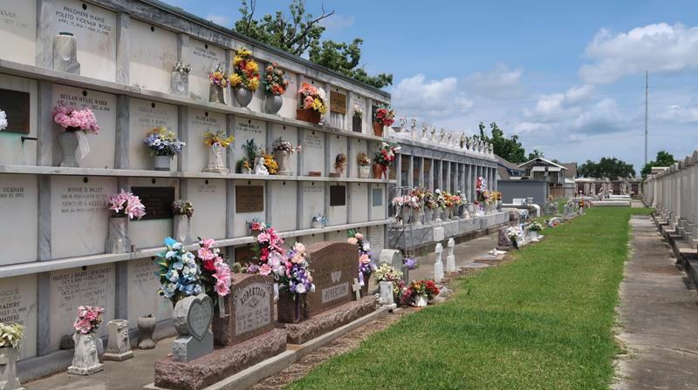

Kathleen Volion, passed away Saturday, July 11, 2015, at the age of 62. Wife of the late Albert Volion, Sr. Daughter of Doris Jacob and the late Wilbert Jacob.
Mother of Emily (fiancée, Jarrett Strode) Volion, Shirley (David) Webre, Sr., Albert (Brandy) Volion, Jr., and Thomas (Stephanie) Volion. Dear friend of Nicky Scioneaux. Also survived by 17 grandchildren, 13 great grandchildren, a host of cousins, nieces, nephews, other relatives and friends.
A wake will be held at The Baloney Funeral Home, LLC, 1905 W. Airline Highway, Laplace, La., on Tuesday, July 14, 2015, from 6:00 p.m. until 9:00 p.m. The funeral will be held at The Baloney Funeral Home, LLC, on Wednesday, July 15, 2015, for 10:00 a.m. Visitation will be from 8:00 a.m. until time of service. Father Armani will be officiating. Interment will be at St. Peter Catholic Church Cemetery, Reserve, LA.
Special thanks to St. Catherine's Hospice and East Jefferson General Hospital CCU Department.
The New Orleans Advocate, Louisiana
Jul. 13 to Jul. 14, 2015

