Thomas Volion Jr.
1944 – February 17, 2006

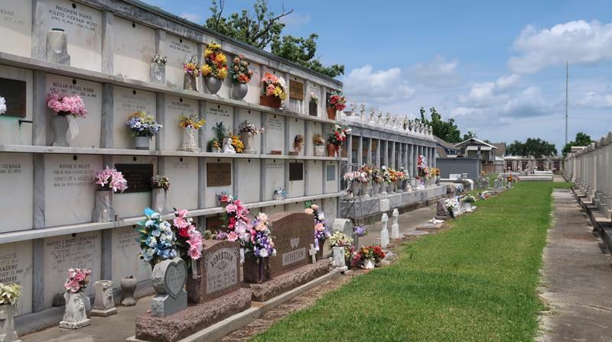

VOLION JR., THOMAS - A retired welder with Volks Inc., and a resident of Galvez, he died at 7:30 a.m. on Friday, Feb. 17, 2006, in Prairieville. He was 62 and a native of Garyville.
Visiting at Ourso Funeral Home, Gonzales, on Monday, Feb. 20, from 6 p.m. to 9 p.m. Visiting resumes at the funeral home chapel on Tuesday, Feb. 21, from 9 a.m. until religious service at 11 a.m. Graveside service at St. Peter Catholic Church Cemetery, Reserve, on Tuesday at 1:30 p.m.
He is survived by his wife, Hope Louise Dupre Volion; a daughter, Yvonne Solis, Ventura, Calif.; son, Ronald Joseph Solis, Lake Elsinore, Calif.; three sisters and two brothers-in-law, Ernestine and Leo Lambert, Lutcher, and Margaret Volion, and Rita and Joseph "Rick" Meche, all of Reserve; three brothers and a sister-in-law, Albert and Kathleen Volion, Norman Volion and Allen Volion, all of Reserve; four grandchildren and a great-grandchild.
Preceded in death by his parents, Thomas Sr. and Frezine Moran Volion; and two sisters, Shirley Borne and Jennette Perry.

The Advocate, Baton Rouge, Louisiana
Feb. 20, 2006

