Aurelie Therese (Breaux) Waguespack
July 9, 1939 – November 23, 2010

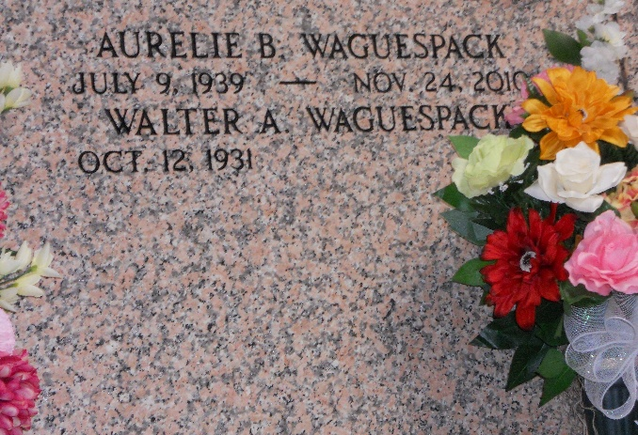
Photo by Team T-Lo

Aurelie Breaux Waguespack, a retired data processor with J. Ray McDermott for 26 years, passed away on Wednesday, November 24, 2010.
Beloved wife of Walter A. Waguespack for the past 50 years. Daughter of the late Eves A. Breaux , Jr. and Alice Chiasson Breaux. Sister of Betty Breaux Defiore (husband Nick). Sister-in-law of Helen W. Borne, Carolyn W. Monroe and Irene W. Monica (husband Dr. Ron Monica). Aunt of Gwen Defiore Faucheaux (husband Steve), Nickie Defiore Castrogovannie, Glenda Defiore Shaheen (husband Glenn), and Colleen Defiore Ourso (husband Russell). Also survived by a host of Waguespack nieces and nephews. Special Friend of Carl and Janet Chiasson. She was a loving, caring person who never met a stranger. Age 71 years, a native of Lockport, LA and a resident of Marrero, LA for the past 32 years.
Relatives and Friends of the Family are invited to attend the visitation at MOTHE FUNERAL HOME, 2100 Westbank Expressway, Harvey, LA on Sunday, November 28, 2010 from 6:00 PM until 9:00 PM and Monday, November 29, 2010 from 8 AM until 12:30 PM. A Funeral Mass will follow at Visitation of Our Lady Catholic Church, Marrero, LA at 1 PM followed by a Prayer Service at St. Peter's Catholic Church, Reserve, LA at 3:00 PM. Interment St. Peter's Mausoleum, Reserve, LA.
In lieu of flowers, donations may be made in her memory to the American Cancer Association of Greater New Orleans, LA.

The Times-Picayune, New Orleans, Louisiana
Nov. 27 to Nov. 29, 2010

