Dianne (Webre) Waguespack
September 15, 1948 – May 26, 2011

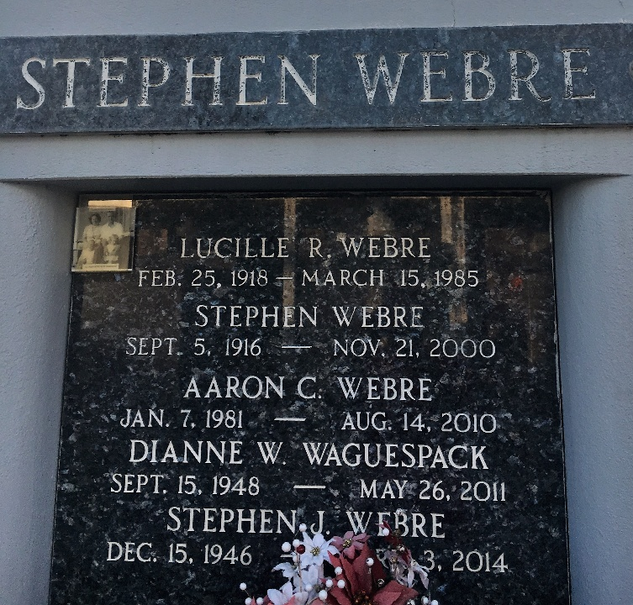
Photo by Team T-Lo

Dianne Webre Waguespack passed away on Thursday, May 26, 2011. Beloved wife of Daniel (Bean) Waguespack. Mother of Deborah Waguespack Cambre (James) and Daniel Waguespack Jr. (Aubrey). Also survived by 4 grandchildren. Daughter of the late Stephen and Lucille Webre. Sister of Russell and Stephen Webre. Age 62. A native and resident of LaPlace, LA. Relatives and friends are invited to attend services. Visitation at Millet-Guidry Funeral Home, 2806 W. Airline Hwy., LaPlace, LA, on Wednesday, June 1, 2011 from 12:00 noon to 1:00pm, followed by Memorial Services in the Funeral Home Chapel at 1:00 pm. Burial in St. Peter Cemetery, Reserve, La.

The Times-Picayune, New Orleans, Louisiana
May 29, 2011

