Haydel Antoine Waguespack
January 12, 1934 – December 17, 2016

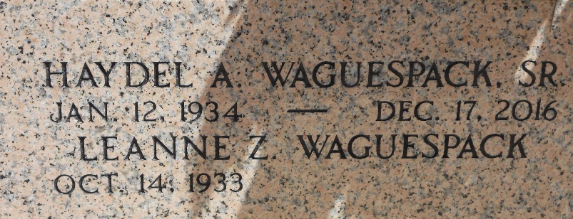
Photo by Team T-Lo

Haydel (Wag) Antoine Waguespack, Sr., age 82, died on December 17, 2016 after a brief struggle with cancer. Wag is survived by his wife of 60 years, LeAnna Zeringue Waguespack and 4 sons: Kirk (Doreen), Bradley (Debbie), Dale (Jill), and Haydel “Boo” Jr. (Tammy). He leaves behind 5 grandchildren: Jacob “Dusty” Waguespack, Amber W. Millet, Taylor W. Cantillo, BJ Waguespack, Riley Waguespack and 5 great-grandchildren. He is also survived by sisters, Jewell Cuccia, Blanche Troxclair, and Gaynell Bourgeois.
Mr. Waguespack was preceded in death by his parents, Sidney P. Waguespack and Blanche H. Waguespack and siblings Sidney P. Waguespack, Jr., Elia Waguespack, and Marcelle Haydel.
He was a native of Vacherie, LA and a resident of Garyville, LA for 58 years. He proudly served his country as a member of the National Guard. During his career as a delivery/salesman, he worked for Hotard Distributing, Matherne’s Distributing, E. J. Martin Distributing, and Weber Supermarket. Wag enjoyed hunting deer and rabbit as an honorary member of Garyville Hunting Club. He also enjoyed spending time in his garden and with friends at Randy’s Bar and friend Cootsie’s home. He will be missed by family and friends.
A visitation in his honor will be Wednesday, December, 21, 2016 from 9:00 a.m. until funeral time at 11:00 a.m. followed by a Mass of Christian Burial at St. Hubert Catholic Church in Garyville. LA. Burial will be in St. Peter Cemetery in Reserve, LA.

Rose Lynn Funeral Services, Lutcher, Louisiana

