Horace A. Waguespack
August 2, 1908 – December 29, 2005

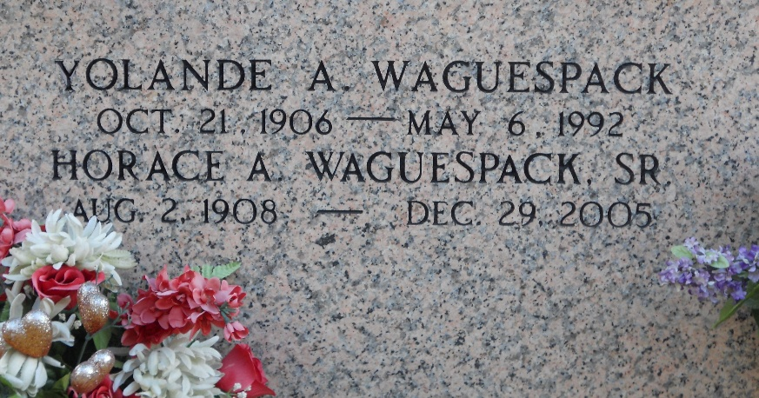
Photo by Team T-Lo

Horace A. (Red Eye) Waguespack, Sr., on Thursday, December 29, 2005 at 10:23 P.M. Beloved husband of the late Yolande Aubert Waguespack.
Father of Horace, Jr., Earl and Daniel (Bean) Waguespack, Sr., Glendora Rich and Ethel Waguespack. Also survived by 7 grandchildren and 7 great grandchildren. Brother of the late Albin, Freddie and Claude Waguespack and Claudia Boe. Age 97. A native of Wallace and resident of Garyville for the past 80 years.
Relatives and friends of the family, also members of The Holy Name Society, are invited to attend services. Visitation at St. Hubert Catholic Church, Garyville, LA. on Tuesday, January 3, 2006 from 9 AM to 11 AM, followed by religious services at 11 AM. Burial in St. Peter Cemetery, Reserve, LA. Arrangements by MILLET-GUIDRY FUNERAL HOME, LAPLACE, LA.
The Times-Picayune, New Orleans, Louisiana
Dec. 31, 2005

