Leanne (Zeringue) Waguespack
October 14, 1933 – September 30, 2018

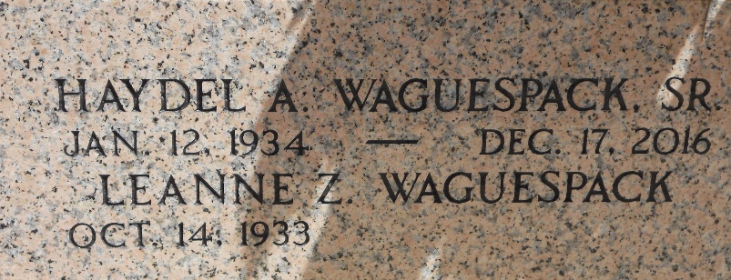
Photo by Team T-Lo

Lee Anna Z. Waguespack, 84, passed away on Sept. 30, 2018, with her sons by her side. Lee Anna is survived by four sons, Kirk (Doreen), Bradley (Debbie), Dale (Jill) and Haydel “Boo” Jr. (Tammy) Waguespack.
She leaves behind five grandchildren, Jacob “Dusty” Waguespack, Amber W. Millet, BJ Waguespack, Taylor W. Cantillo and Riley Waguespack; two step grandchildren, Derik St. Pierre and Danielle St. Pierre and eight great grandchildren, with one on the way.
She was preceded in death by husband Haydel “Wag” Waguespack Sr., parents Horace and Maggie Zeringue, sister Sue Acosta and brother Harold Zeringue.
Lee Anna loved playing bingo and reading books. She belonged to the Garyville Ladies of VFW Auxiliary. She was kindhearted and will be missed by all.
A visitation will be held in her honor on Friday, Oct. 5 from 9:30 a.m. until a Mass of Christian Burial at 11:30 a.m. at St. Hubert Catholic Church in Garyville. Burial will follow in the St. Peter’s Cemetery in Reserve.

L’Observateur, LaPlace, Louisiana
October 1, 2018

