Walter Allen Waguespack
October 12, 1931 – March 10, 2020

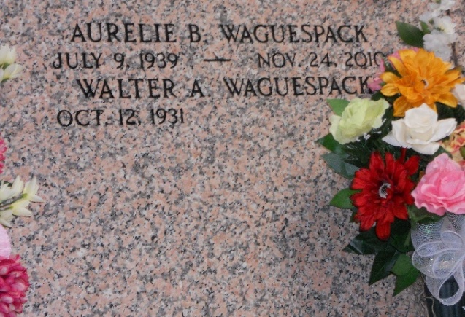
Photo by Team T-Lo

Walter Waguespack died March 10, 2020 at Our Lady of the Lake Hospital in Baton Rouge, Louisiana. Son, brother, husband, uncle, godfather and friend, Walter was beloved by everyone who knew him for his congeniality and friendly spirit. Most of his life was spent in Reserve and Marrero.
On October 12, 1931, he was born in Reserve, LA to Ben Waguespack, Sr. and Lezian Vicknair Waguespack, both deceased. He is also preceded in death by his lovely and cherished wife, Aurelie Breaux Waguespack; his siblings, Helen Waguespack Borne, Ben Waguespack, Jr. and Carolyn Waguespack Monroe; and his nephews, Whit Borne and Brett Waguespack.
Walter grew up in Reserve, and attended Leon Godchaux grammar and high schools. He was an outstanding running back on the Reserve Wildcats football team in the late 1940s and early 1950s. He was an all around athlete, also running track and playing baseball. He received a full scholarship to play football in Baton Rouge with the LSU Tigers. He was drafted during the Korean Conflict and served the U.S. Army in Roswell, New Mexico, the site of the Army's rocket testing grounds. After discharge he returned home to Louisiana and began his career at Shell Oil Co. in Norco. After retirement, he and Aurelie enjoyed traveling in their Motor Home throughout the United States, with Branson, Missouri being their favorite stop.
Walter loved growing vegetables, lots of vegetables, which he and Aurelie unselfishly shared with family and friends. Both country and Cajun music gave him much pleasure. Walter also liked to cook and was known by friends and family for his secret creamy praline recipe which no one has yet to duplicate.
He is survived by his sister, Irene Waguespack Taylor Monica. In 1951, they shared the honor of being King and Queen of Reserve High School's annual Carnival Ball, the only brother-sister duo to ever rule at this heralded event. Walter is also survived by Aurelie's nieces: Gwen Faucheaux, Nickie Long, Glenda Shaheen, Coleen Ourso and their families. He will also be greatly missed by his Waguespack nieces and nephews and their families: Stanley Borne, Paulette Borne Virnich, Judy Borne Hartman, Dennis Borne, Amy Borne Ryan, Jeff Monroe, Jennifer Monroe Cedro, Melanie Monroe Hart, Katy Monroe Kuntz, Susan Waguespack Laurent, Doriane Taylor Usner, Matthew Taylor and many cousins from his Vicknair family. Walter and Aurelie had a special relationship with their niece and nephew, Glenda and Glenn Shaheen. There was a special bond between them. Walter also benefitted from lifelong friends, Janet and Carl Chiasson who were always there for him.
Funeral Services on Saturday, March 14, 2020 at St. Peter's Church in Reserve, LA with visitation beginning at 10:00 AM and Mass at 12:00 noon. Father Ray Hymel, Jr. will be the celebrant. Burial will be in St. Peter's Cemetery. If inclined to send flowers, may we suggest a kindly deed for Lent: A floral bouquet can bring joy to residents of the Reserve Veterans Home or Twin Oaks Nursing Home in Laplace in honor of Walter. Masses are also welcome. "Make someone happy."

Rose Lynn Funeral Home, Lutcher, Louisiana
June 26, 2022

