Cheryl (Barbier) Waits
February 17, 1945 - February 27, 2025

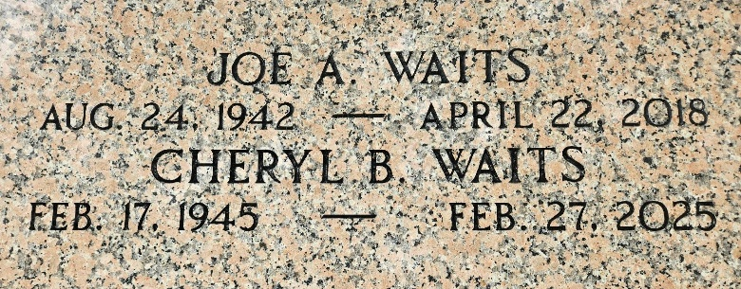
Photo by Team T-Lo

Cheryl Barbier Waits passed away on Thursday, February 27, 2025 at the age of 80. She was born in New Orleans, LA and was a resident of LaPlace, LA. Cheryl lived her life for her family and will be sadly missed by all who loved her. She was a devout catholic and parishioner of Ascension of Our Lord Catholic Church.
Beloved wife of the late Joe Waits, Sr. Loving mother of Angela Ledo (Edward), Natalie Guidry (Troy) and Joe Waits, Jr. (Tammy). Grandmother of Jessica Vicknair, Nancy Gaspard, Troy Guidry, Jr., Taylor Guidry, Travis Guidry, Jodie Waits, Blake Ledo, Ian Ledo, Trevor Ledo, Genna Guidry, Tanner McDonald, Thomas Waits, and Tristen Guidry. Daughter of the late Adeline Kinler Barbier and Misael Barbier, Sr. Sister of Vernon Barbier and the late Misael Barbier, Jr. and Janet “Susie” Barbier Hidalgo. Also survived by 9 great grandchildren and many nieces and nephews.
Relatives and friends are invited to attend the Visitation and Funeral Mass at Ascension of Our Lord Catholic Church, 1900 Greenwood Dr., LaPlace, on Thursday, March 6, 2025. Visitation will be held at church from 10:00 a.m. to 12:00 p.m. followed by a Funeral Mass 12:00 p.m. Interment in St. Peter Cemetery, Reserve, LA.
Millet-Guidry Funeral Home, LaPlace, Louisiana

