Dixie Marie (Fontenot) Waits
August 9, 1941 – May 19, 2007

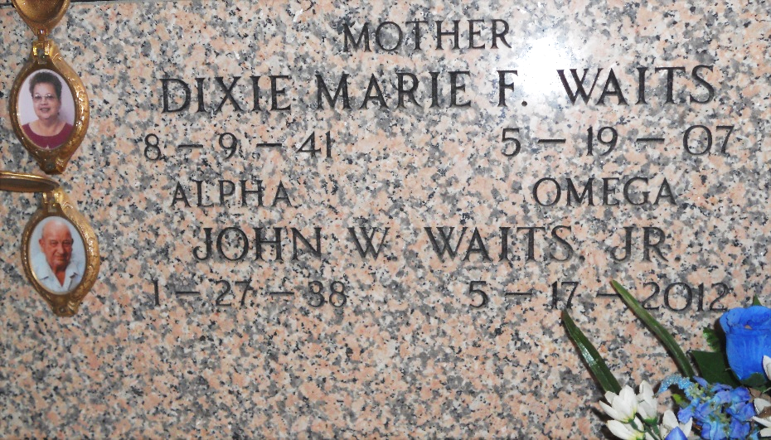
Photo by Team T-Lo

Dixie F. Waits on Saturday, May 19, 2007 at 11:48 PM.
Beloved wife of John Waits, Jr. Mother and mother-in-law of Wes and Allison Waits, Stuart Shane and Tanya Waits, and Mitch and Stefany Waits. Grandmother of Zachary, Mason, and Kyle Waits.
Daughter of the late Sammy and Irma Fontenot. Sister of Brenda Stelly, Mike and Reggie Fontenot. Age 65, a native of Opelousas, LA and resident of Reserve, LA for the past 37 years.
Relatives and friends of the family, also employees of St. James Hospital are invited to attend the services. Visitation at Millet-Guidry Funeral Home, 2806 West Airline Hwy. LaPlace, LA, on Monday, May 21, 2007 from 5:00 PM to 9:00 PM and on Tuesday from 8:00 AM to 9:45 AM. Followed by religious services at St. Peter Catholic Church, Reserve, LA at 10:00 AM. Burial in St. Peter's Cemetery, Reserve, LA.

The Times-Picayune, New Orleans, Louisiana
May 21, 2007

