Joe Allen Waits
August 24, 1942 – April 22, 2018

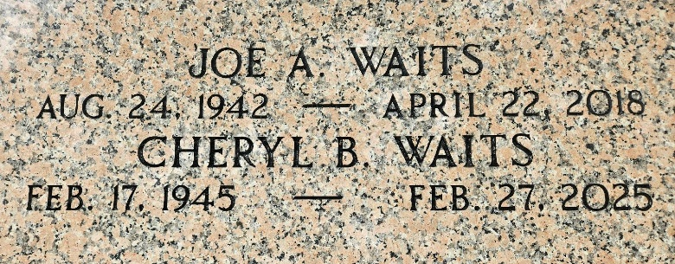
Photo by Team T-Lo

Joe A. Waits passed away on Sunday, April 22, 2018 at the age of 75. He was born in Lafayette, raised in Big Cane and a longtime resident of LaPlace.
Joe served in the U. S. Army and later retired from Marathon Petroleum in Garyville. He was an avid LSU sports fan.
Beloved husband of Cheryl Barbier Waits. Loving father of Angela Ledo (Ed), Natalie Guidry (Troy) and Joe Waits (Tammy). Grandfather of Jessica Vicknair (Kody), Nancy Waits, Troy Guidry Jr., Taylor Guidry (Tammy), Travis Guidry (Leica), Genna Guidry, Tristen Guidry, Blake Ledo, Ian Ledo, Trevor Ledo, Jodie Waits, Tanner Waits and Thomas Waits. Also survived by many great-grandchildren.
Son of the late John and Mary Bell Worley Waits. Brother of Jessie Beard, Myrtle Billeaudeau, Messie Billeaudeau, Bolden Waits, William Waits and the late John Waits Jr. Also survived by many nieces and nephews.
Relatives and friends are invited to attend the Funeral Service at Millet-Guidry Funeral Home, 2806 W. Airline Hwy., LaPlace on Friday, April 27, 2018 at 12:00 p.m. Visitation will be held from 10:00 a.m. to 12:00 p.m. Interment in St. Peter Cemetery.

The New Orleans Advocate, Louisiana
Apr. 23 to Apr. 27, 2018

