John Wesley Waits Jr.
January 27, 1938 – May 17, 2012

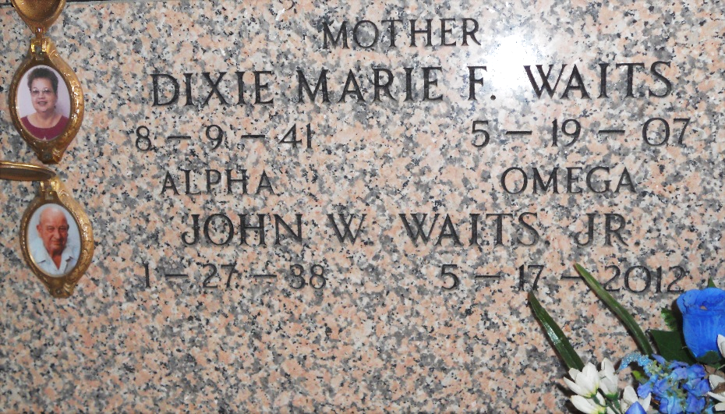
Photo by Team T-Lo

John W. Waits, Jr. passed away on Thursday, May 17, 2012. Beloved husband of the late Dixie F. Waits. Father of Wes (Allison), Stuart Shane (Tanya) and Mitch Waits (Stefany). Grandfather of Zachary, Mason, Kyle, Sarah and Kaitlyn Waits. Son of the late John and Mary Waits. Brother of Bolden, Joe and William Waits, Jessie Beard, Myrtle Billeaudeau and Messie Billeaudeau. Age 74. A native of Big Cane, LA and a resident of Reserve, LA.
Relatives and friends are invited to attend services. Visitation at Millet-Guidry Funeral Home, 2806 W. Airline Hwy., LaPlace, LA on Sunday, May 20, 2012 from 5:00pm to 9:00pm and on Monday from 8:00am to 9:30am, followed by Mass at St. Peter Catholic Church, Reserve, LA at 10:00am. Burial in St. Peter Cemetery, Reserve, LA.

The Times-Picayune, New Orleans, Louisiana
Saturday, May 19, 2012

