Ferdinand Joseph Wallace Sr.
1932 – January 30, 2023

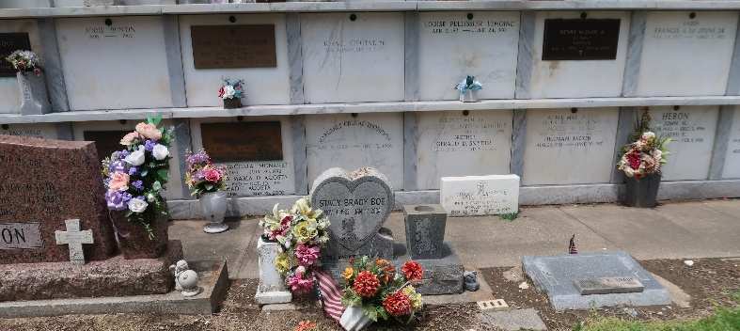

Ferdinand Joseph Wallace, Sr., "Tommy", at the age of ninety, was called to his eternal rest on Monday, January 30, 2023, at the VA Hospital in New Orleans, LA.
Son of the late Albertha Madere Wallace and Willie Wallace, Sr. Husband of the late Diane Ford Wallace. Father of Rosalind Manuel, Marisa, Takiya, Ferdinand, Jr., and Shawn (Shiria) Wallace. Brother of Willie (Lorraine) Wallace, Jr., Shirley Cambre (the late Hebert Cambre), Daphne McClean (the late Steve McClean), Evelyn Wallace, the late John Wallace (the late Patricia Wallace), the late Geraldine Holland (the late Ernest Holland), and the late Gwendolyn Wallace. Also survived by six grandchildren Cardell Wallace, Brenon Bowser, Kolbi (Lareesa) Belvin, Ferdinand Wallace, III, William Wallace, and Ayanna Wallace, one great-grandchild Armani Belvin, and a host of nieces, nephews, other relatives, and friends. A native and a resident of Reserve, LA.
Family, relatives, also priest and parishioners of Our Lady of Grace Catholic Church, members of King David Baptist Church, First Community Antioch Baptist Church, Golden Grove Baptist Church, and all neighboring churches, employees of St. John The Baptist Parish Government office (Dept of Community Services), ASM GLOBAL-Caesars Superdome/Smoothie King, State of Louisiana Department of Revenue, Matt Bowers Ford, St. John the Baptist Parish School Board, and Robottom Mortuary and the members of Knights of Peter Clavier St. Catherine Council #73 and Phi Beta Sigma are invited to attend the Funeral Mass at Our Lady of Grace Catholic Church, 772 LA-44, Reserve, LA, on Saturday, February 11, 2023, at 10:00 am. Fr. Godwin Ani, SSJ, Celebrant. Interment in St. Peter Cemetery, Reserve, LA. Visitation at the above-named church from 8:15 am until Mass time. Recitation of the Rosary at 9:15 am.

The Times-Picayune, New Orleans, Louisiana
February 10, 1923

