Gwendolyn Wallace
December 19, 1927 – March 29, 2015

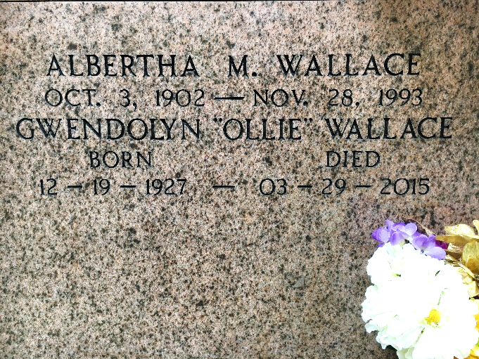
Photo by Team T-Lo

Gwendolyn "Ollie" Wallace on Sunday, March 29, 2015 at Chateau St. James Rehab and Retirement, Lutcher, LA. Daughter of the late Albertha Madere and Willie Wallace, Sr.
Mother of Cheryl Wallace Montgomery (Elvin) and Eric Wallace (Vernell) Sister of Shirley Cambre, Daphne McClean, Evelyn Wallace, Ferdinand "Tommy" Wallace (Diane), Willie Wallace, Jr. (Lorraine), the late John Wallace and Geraldine Holland. Also survived by 4 grandchildren, 4 great grandchild-ren, 3 step grandchildren and a host of nieces, nephews, cousins, other relatives and friends. Age 87 years. A native and resident of Reserve, LA.
Relative and friends of the family, also priest and parishioners of Our Lady of Grace Catholic Church and all neighboring churches are invited to attend the Funeral Mass at Our Lady of Grace Catholic Church, 772 Hwy 44 (River Road), Reserve, LA on Tuesday, April 7, 2015 at 10:00 AM Father Christopher Amadi, Celebrant Interment St Peter Cemetery, Reserve, LA Visitation at the above named church from 8:15 AM until Mass time. Rosary at 9:15 AM SERVICED BY ROBOTTOM.

The Times-Picayune, New Orleans, Louisiana
March 31 – April 5, 2015

