Judith (Fontenot) Warner
September 7, 1959 - September 6, 2025

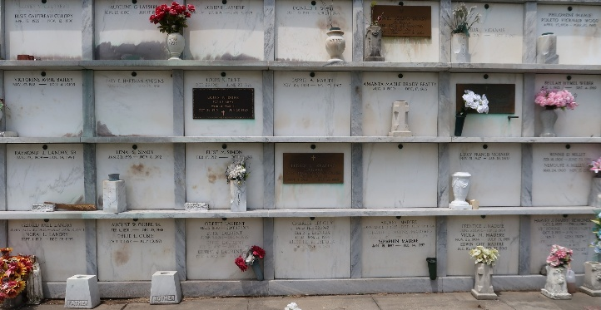

Judith Warner, a resident of LaPlace, LA passed away on Saturday September 6, 2025 at the age of 65.
Beloved wife of Mickey Warner for 46 years. Loving mother of Nicholas Warner, Cliff Warner (Holly), Brooke Gonzalez. Grandmother of Jonathan Warner, Dean Warner, Kaylee Gonzalez.
Daughter of Anthony Fontenot and the late Virginia Bornes Fontenot. Sister of Jessica Entremont (the late Barry), Jodie Fontenot, Jena Schexnayder, and the late Anthony Leeroy Fontenot, Jr. Also survived by numerous cousins, nieces, and nephews.
Judith loved her family above all else, especially her grandchildren. She and Mickey loved cruising. As long as she had her coffee and grandkids she was as happy as she could be.
Relatives and friends are invited to attend the Visitation and Funeral Service on Saturday September 13, 2025 at St. Peter Catholic Church, in Reserve. Visitation from 9:00 a.m. -11:00 a.m. with the Funeral Service to begin at 11:00 a.m. A private burial will take place at a later date.

Rose Lynn Funeral Home, Lutcher, Louisiana
September 11, 2025

