Wendy (Grow) Washington
February 1, 1976 – May 11, 2026

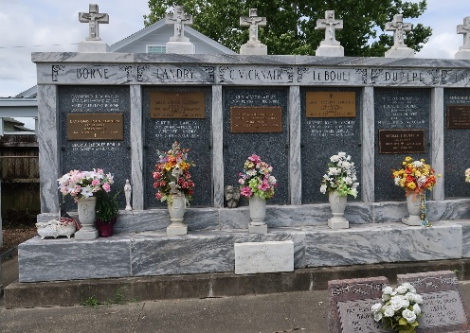

On Monday, May 11, 2026, the Angel of the Lord visited the earth and whispered in the ear of His Daughter, Wendy Grow Washington, your assignment on earth is now complete, come on up to your Home in Glory and Rest from your Labors.
Wendy was born to the Parentage of Byron Grow, Sr and Dianne Grow on February 1, 1976. She would join her siblings, Aleshia and Byron Grow, Jr. They were raised in a loving and caring home and were taught the Word of God. The three of them were inseparable.
She was educated in The St. John the Baptist School District and graduated in May of 1994 from East St. John High School. Wendy had other plans and decided to attend River Parish Community College (RPCC) and obtained of her Bachelor Degree, as well as obtaining a Degree in Process Tech from River Parish Vocational School.
That still wasn't enough and in 2016, Wendy obtained her Manicurist License and chose that as her Profession and worked along beside her sister, Aleshia, at her Nail Salon, Metamorphosis 180 LLC, where they did more than hands and feet. Their Salon became their Ministry they both shared the Word of God with their Clients. Wendy's number one Goal was to Spread the Gospel of Christ, which is found in I Corinthians 15:1-4. In 1 Corinthians 15:1-4, the Apostle Paul defines the foundational core of the Christian faith: the "Gospel" (or Good News). He reminds the Corinthian church that this message is the source of their salvation, detailing that Christ died for our sins, was buried, and was raised on the third day, all in accordance with the Scriptures.
Wendy met and married, Brian Washington, and their union was Blessed with a son, Jeremiah M. Washington. In her passing she leaves to cherish her, Mother, Dianne Grow; Son, Jeremiah M. Washington; Sister, Aleshia Grow; Brother, Byron (Alesha) Grow; Nephews, Ju'Micheal, Ja'Mar, and Joshua Grow; Great Niece, Amenia Grow; Godmother, Henrietta Jessie; Godchild, Ayanna Ranton and a host of Aunts, Uncles, Cousins, other relatives and friends. She was preceded in death by her Father, Byron Grow, Sr.
Private services were held on Wednesday, May 27, 2026, at the Patrick H. Sanders Funeral Home. Interment at St. Peter Catholic Cemetery.

Patrick H. Sanders Funeral Home, LaPlace, Louisiana

