Bernice (Levet) Weber
November 18, 1920 – October 10, 2008

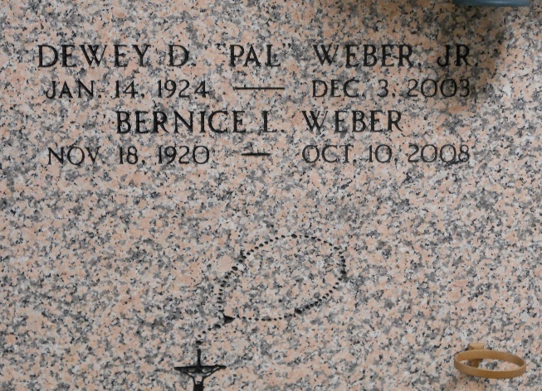
Photo by Team T-Lo

Bernice "Bonnie" Levet Weber, age 87, surrounded by family, passed away on Friday October 10, 2008 at 3:00A.M. She was preceded in death by her loving husband Dewey (Airline, Pal) Weber, Jr. Mrs. Weber was born in Reserve and lived in LaPlace.
Mother and mother-in-law of Wayne and Claudia Weber, Paulette and Dean Hall and the late Danny Weber. Daughter of the late John and Olive Levet. Sister of the late Lemonce Levet, Amy Jacob, Thelma Stout and Percy Levet.
Survived by a brother Ernest Levet and a sister Gloria Vicknair. Also survived by 3 grandchildren, 6 great-grandchildren, 2 step grandchildren and 4 step great-grandchildren.
Special thanks to the staff at Twin Oaks Nursing Home in LaPlace.
Relatives and friends of the family are invited to attend services. Visitation at Millet-Guidry Funeral Home, 2806 W. Airline Hwy., LaPlace, La. on Monday, October 13, 2008 from 9:00AM to 11:30AM. Religious Services at Ascension of Our Lord Catholic Church, 1809 Greenwood Drive, LaPlace, La. at 12:00 noon. Burial in St. Peter Cemetery, Reserve, LA.

The Times-Picayune, New Orleans, Louisiana
Oct. 12, 2008

