Clelie (Vicknair) Weber
October 4, 1879 – May 27, 1959

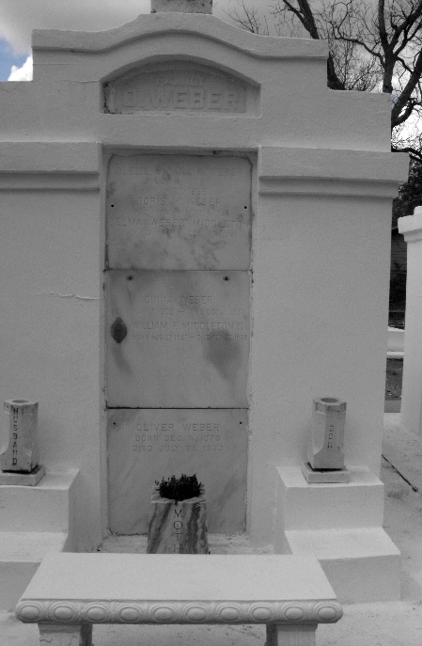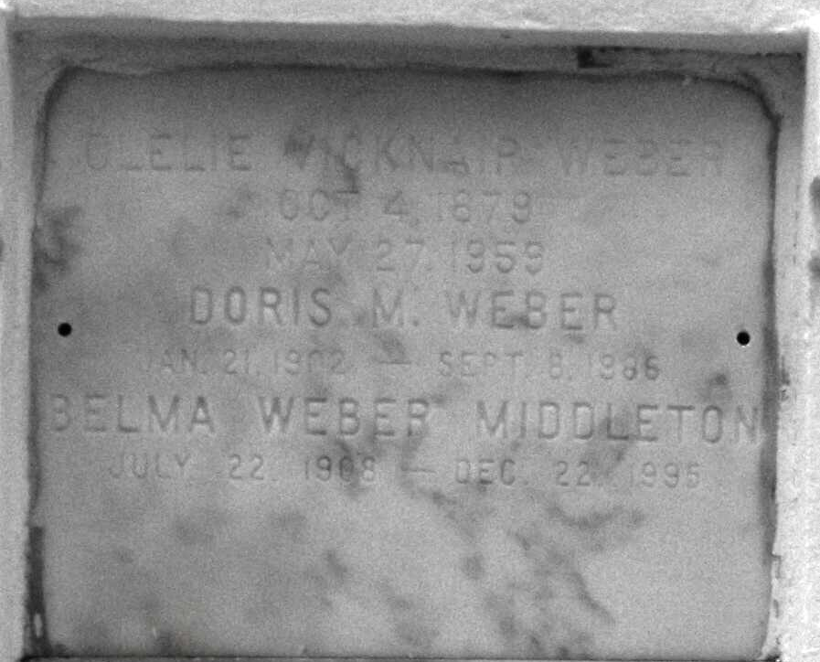
Photos by Mary Agnes Hammett

Clelie Vicknair Weber, a native and resident of Reserve, Louisiana, died Wednesday, 27 Mar 1959, at 9:35 p.m. at age 79 years.
She was the wife of the late Oliver Weber and the mother of Mrs. Paul Spedale of Baton Rouge, Mrs. Maxie Primeaux and Miss Doris Weber of New Orleans, and Mrs. W. F. Middleton of Reserve, and the late Cina Weber. She was the sister of Mrs. Numa Simon of Marrero, Louisiana, Mrs. Angeline Cassagne and Miss Luceppe Vicknair of Reserve. Also survived by three grandchildren and five great-grandchildren.
Services were Friday, 29 May 1959, at St Peter Church, Reserve, with interment in St Peter Cemetery, Reserve.
The Times-Picayune, New Orleans, Louisiana
29 May 1959

