Doris (Songy)Weber
April 23, 1921 – April 26, 2009

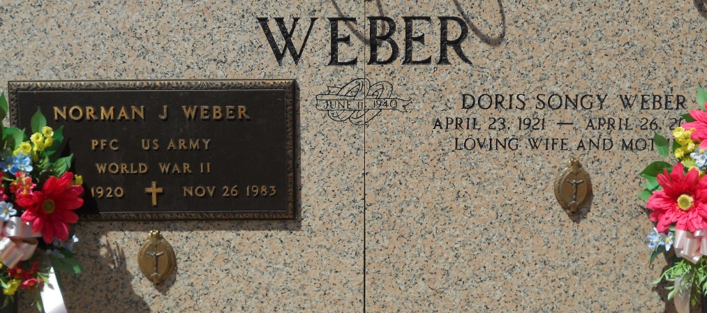
Photos by Team T-Lo

Doris Songy Weber, age 88, on April 26 at 6:30AM in Lutcher, LA. Loving and dedicated wife of the late Norman "Shot" Weber.
Mother and mother-in-law of David and Jeanne Bourgeois Weber, Philip and Kathleen Casio Weber, Melvin and Irene Montz Weber, Brian and Donna Riner Weber, and Harvey and Tricia. Caronna Weber.
Daughter of the late Palmyre Hymel and Justin J. Songy. Sister and sister-in-law of the late Agnes Songy, May and Otto Becnel, Denise and June Cambre, Pauline and Edward Curren, Clarisse Songy and Edmond and Virgina J Songy. Daughter-in-law of the late Jules 'Noe" and Norma Weber. Sister-in-law of Jules "Coloon" and Mabel J. Weber, Howard and the late Elma Mae P. Weber, Earline W. and the late Wilbert Mollere, the late Noelie W. and Felix Breaud, Marilyn D. and the late Hayes "Creepy" Weber, and Helen W. Blouin. Grandmother of Shane Weber, Angela W. Robinson, Destry Weber, Emmett Weber, Rusty Weber, Annette W. Becnel, Loretta Weber, Bart Weber, Robert Weber, Kristen W Burton, Liane W. St. Martin, Cash Weber and the late John Weber. Also had 4 step grandchildren, 24 great grandchild-ren.
Born on April 23, 1921 in Wallace Louisiana and a resident of Reserve since 1933. She was a parishioner of St. Peter Catholic Church, a member of the Catholic Daughters, Ladies Altar Society and the Queen of the Reserve Centennial Celebration in 1960. She was the owner of Webers Supermarket in Reserve for approx. 28 years.
The family would like to thank the entire staff at Riverlands Health Care Center, St James Hospital, and St. Catherine's Hospice for their care and attention. Funeral Services at Millet-Guidry Funeral Home, 2806 W. Airline Hwy., Laplace, LA. Visitation on Tuesday, April 28 from 6-9 PM and on Wednesday, April 29 from 8-10AM followed by Mass and burial at St. Peters Catholic Church and Cemetery in Reserve.
The Times-Picayune, New Orleans, Louisiana
April 28, 2009

