Glynn J. Weber
March 14, 1941 – September 5, 2004

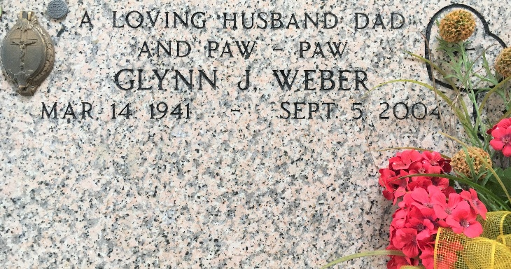
Photo by Team T-Lo

Glynn J. Weber, owner and operator of Spillway Bar in Norco, LA passed away at River Parishes Hospital on Sunday, September 5, 2004 at 8:16 PM. He lived 63 wonderful years. He was a very loving, compassionate and generous man who touched the lives of all those around him.
Beloved husband of Carolyn Hotard Weber of Reserve, LA. Exceptionally loving father of Troy M. Weber of Paulina, LA and Roxs Anne W. Greaud of Norco, LA. Wonderful father-in-law of Terry W. Greaud and Sandy M. Weber. Proud, loving and caring grandfather of Katelyn M. Greaud and Paige M. Weber. Brother of Perrin Weber, Jr. of Norco, LA, Merlene St. Pierre of LaPlace, LA and Deanna Maus of Reserve, LA.
Beloved son of the late Peran (Peg) Weber, Sr. and Clementine (Teen) Dupuy Weber of Norco, LA. Son-in-law of the late Albert S. (Sheik) Hotard and Marie Stein Hotard. Preceded in death by son Baby Glynn Weber, Jr. and siblings Margaret C. Laurent and Marlvain (To Jo) Weber. Also, survived by sisters-in-law, brothers-in-law, nieces and nephews. A native of Norco, LA and a resident of Reserve for the past 43 years.
Relatives and friends of the family are invited to attend services. Visitation at Millet-Guidry Funeral Home, 2806 W. Airline Hwy., LaPlace on Wednesday, September 8, 2004 from 5PM - 9PM and on Thursday from 8 AM - 9:45 AM followed by a Mass of Christian Burial at St. Peter Catholic Church, Reserve at 10 AM. Burial in church cemetery. In lieu of flowers, masses preferred.
The Times-Picayune, New Orleans, Louisiana
September 8, 2004

