Karen (Vicknair) Weber
July 17, 1965 – March 14, 2018

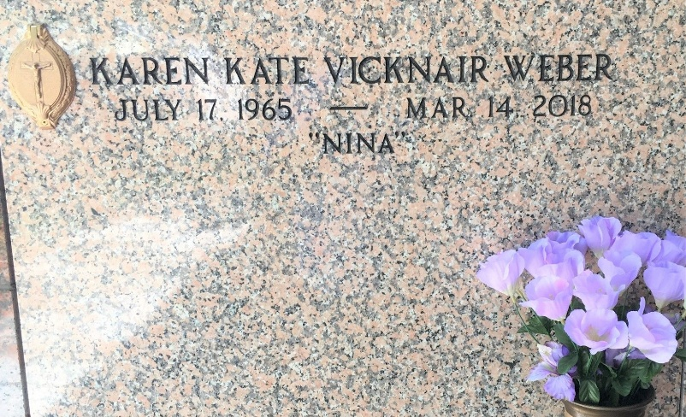
Photo by Team T-Lo

Karen Vicknair Weber passed away on Wednesday, March 14, 2018 at the age of 52. She was a native of Reserve and a resident of LaPlace for 36 years.
Beloved wife of Ronald Joseph Weber for 36 years. Mother of Ashley Weber and Lacie Weber Louque (Kevin). Nina of Brianna Louque (her heart) and Savannah Louque (her soul).
Daughter of Loyce Brack Vicknair and Wilson Joseph Vicknair. Sister of Valerie Scioneaux (David) and Sonya Ocmand (Joel). Daughter-in-law of the late Beulah Hymel Weber and Benedict Weber. Sister-in-law of Glenda Wactor (the late, Willy), Karen Estey (Ronnie), Roxanne Munsch (the late, Les), Sybil Skansi (Nick), Wanda Toland (Terry) and Janice Cheek. Also survived by many nieces and nephews.
Relatives and friends are invited to attend the Funeral Mass at St. Peter Catholic Church, 1550 Hwy. 44, Reserve on Friday, March 16, 2018 at 11:00 a.m. Visitation at the church from 9:00 a.m. to 11:00 a.m. Interment in St. Peter Cemetery.

Millet-Guidry Funeral Home, LaPlace, Louisiana
March 15, 2018

