Layton J. Weber Sr.
February 28, 1961 – April 4, 2011

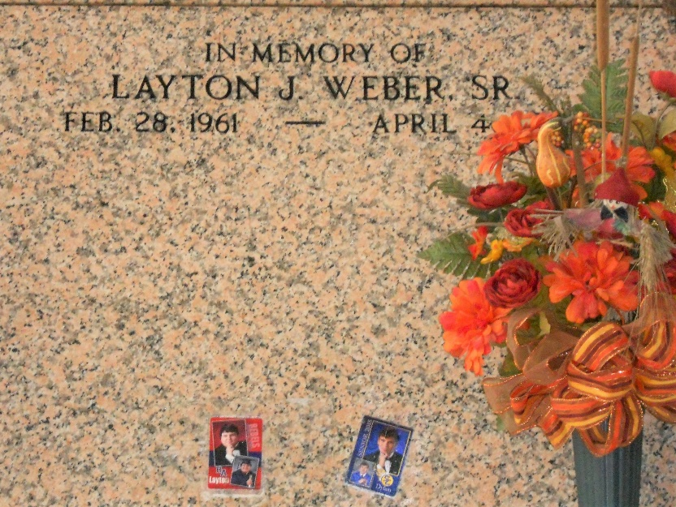
Photo by Team T-Lo

Layton J. Weber, Sr. passed away on Monday, April 4, 2011.

Beloved father of Layton (L.J.) Weber, Jr. Son of Jules and Mabel Weber. Brother of Barry Weber, Sharon Vicknair and the late Brian and Ronnie Weber. Also survived by nieces and nephews. Former husband of Donna Oubre Weber. Age 50 years. A native and resident of Reserve.

Relatives and friends are invited to attend services. Visitation at Millet-Guidry Funeral Home, 2806 W. Airline Hwy., LaPlace, on Wednesday, April 6, 2011 from 9:00am until 11:00am, followed by Religious Services at the Funeral Home Chapel at 11:00am. Burial in St. Peter Cemetery, Reserve.

The Times-Picayune, New Orleans, Louisiana
Apr. 6, 2011

