Lea Marie (Trosclair) Weber
September 3, 1891 – February 7, 1963

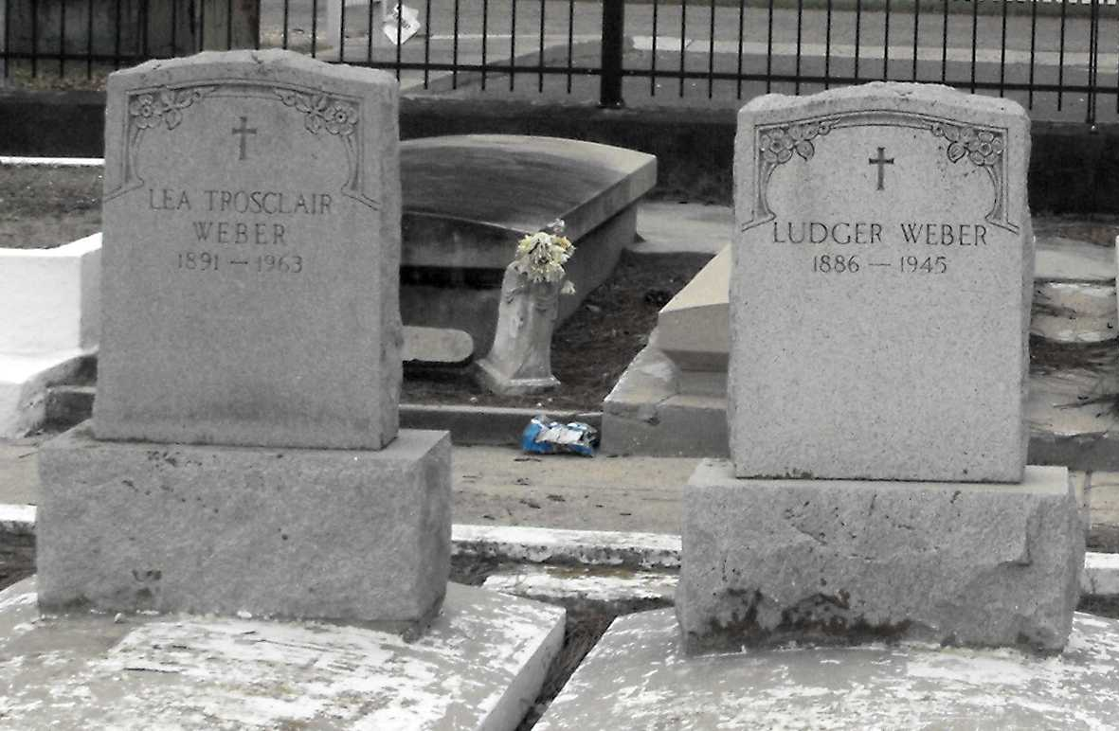
Photo by Mary Agnes Hammett

WEBER – On Thursday, Feb. 7, 1963, at 11:30 o’clock a.m. Lea Marie Trosclair, wife of the late Lutger (sic) Weber, daughter of the late Joseph Trosclair and Eugenie Rodrigue, sister of Mrs. Olide Waguespack, Mrs. Lionel Klibert of Reserve, La., Joseph Trosclair of Harvey, La., and the late Willie Trosclair and Anicet Trosclair. Age 71 years. A native of Chackbay, La., and a resident of Garyville, La.
Relatives and friends of the family are invited to attend the funeral. Services from the Millet Funeral Home, Reserve, La., on Saturday, Feb. 9, 1963, at 9:30 o’clock a.m., religious services at St. Hubert Church, Garyville, La., at 10 o’clock a.m. Interment St. Peter Cemetery, Reserve, La. Parlor will be open Friday, 10 o’clock a.m.

The Times-Picayune, New Orleans, Louisiana
Friday, February 8, 1963, sec. 1, p. 2

