Loretta Marie Weber
August 12, 1967 – September 7, 2016

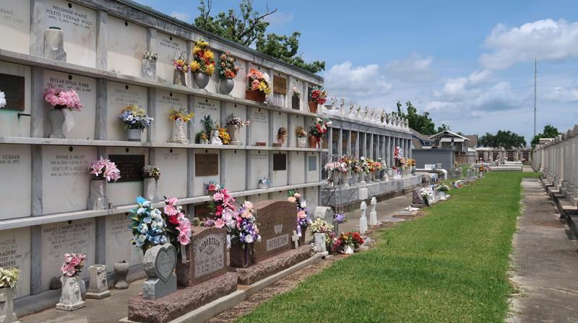

Loretta Marie Weber, 49, departed this life to enter into the loving arms of her Lord and Savior, Jesus Christ. Loretta passed away at her home in Garyville on Wednesday, September 7, 2016. She was the daughter of Penny Torres Chachere of Garyville and Brian (Donna) Weber, of North Augusta, SC.
She is survived by her son, Ryan Caldarera; brothers Bart Weber of Garyville; Robert (Christine) Weber of Jensen Beach, FL; sister Kristin (Brian) Cook of Hernando, MS. nephews and nieces include Jessica and Joshua Weber of Jensen Beach; Sebastian of Garyville, LA; and Brady of Hernando. She is also survived by her maternal grandmother, Anna Torres of Garyville. She was also the step sister of Samuel (Amber) Stump of Atlanta, and had a step niece, Savannah of Lincolnton, GA. Loretta also had a host of loving uncles, aunts and cousins.
Please keep the entire family in your prayers through this most difficult time, for the peace of Jesus that surpasses all worldly peace!
Visitation will be at St. Hubert's Catholic Church in Garyville from 9:00 AM until 11:00 AM on Saturday, September 10, 2016 followed immediately by the funeral Mass at St. Hubert's. Interment will follow in St. Peter's Cemetery in Reserve.
Rose Lynn Funeral Home, Lutcher, Louisiana

