Mabel Mary (Jacob) Weber
February 7, 1933 – June 7, 2011

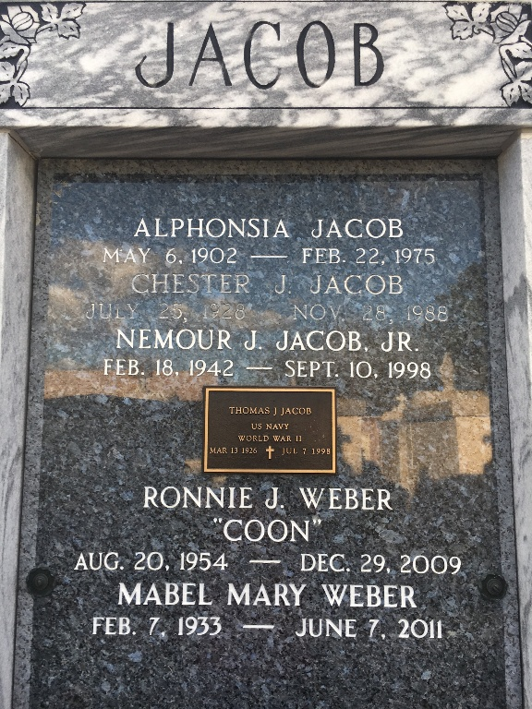
Photo by Team T-Lo

Mabel Jacob Weber passed away on Tuesday June 7, 2011.
Beloved wife of Jules Weber. Mother of Barry Weber, Sharon Vicknair, the late Brian, Ronnie and Layton Weber. Also 10 grandchildren and 6 great-grandchildren.
Daughter of the late Nemour and Alphonsia Jacob. Sister of Irvin Jacob, Barbara Jones, the late Walton, Nemour Jr., Raymond, Chester and Tom Jacob. Age 78. A native and resident of Reserve, LA.
Relatives and friends are invited to attend services. Visitation at Millet-Guidry Funeral Home, 2806 W. Airline Hwy., LaPlace, La. on Thursday, June 9, 2011 from 11:00 am to 1:00 pm, followed by Religious Services at the Funeral Home Chapel at 1:00 pm. Burial in St. Peter Cemetery, Reserve, La.

The Times-Picayune, New Orleans, Louisiana
Jun. 9, 2011

