Norma (Jacob) Weber
September 24, 1896 – April 29, 1979

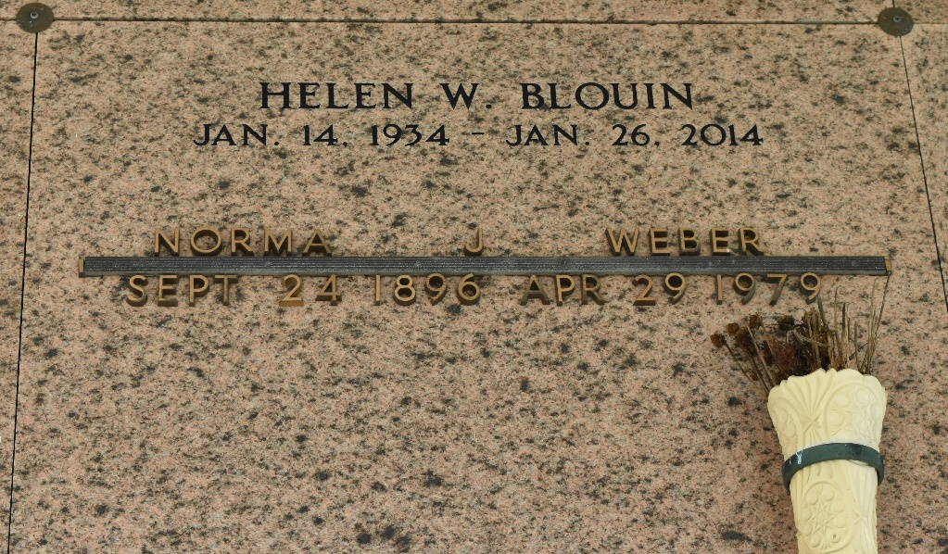

WEBER
Norma J. Weber, on Sunday, April 29, 1979 at 5:15 pm, beloved wife of Noe Weber of Reserve, mother of Noelie Breaud, Earline Mollere, Helen Blouin, Howard, Norman, Jules and Hayes Weber, all of Reserve, La, also survived by 34 grandchildren and 32 great grandchildren, age 82 years old, a native and resident of Reserve.

Relatives and friends of the family are invited to attend the funeral services from Millet Funeral Home, Reserve, La, on Tuesday, May 1st, at 10:00 am, followed by Religious Services at St Peters Catholic Church. Interment in Church Cemetery.

The Times-Picayune, New Orleans, Louisiana
May 1, 1979, p. 14

