Oliver Weber
December 11, 1879 – July 25, 1933

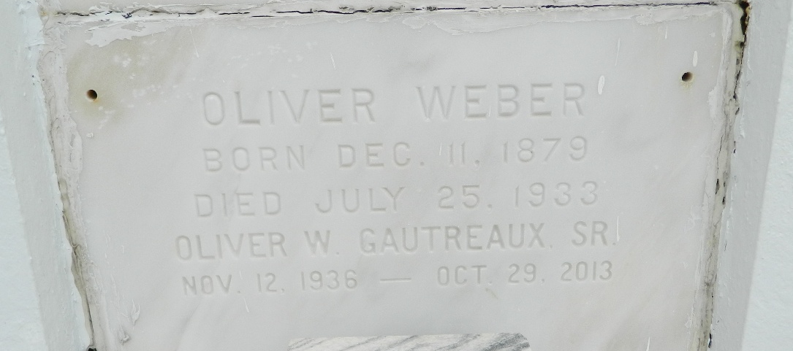

WEBER
Oliver Weber, a native and resident of Reserve, Louisiana, died Tuesday, 25 Jul 1933, at 4:30 a.m. at age 53 years and 7 months.

He was the husband of Clelie Vicknair and the father of Doris, Hilda, Belma, Jeannie and Cinna Weber.

Services were Wednesday, 26 Jul 1933, at St Peter Church, Reserve, with interment in St Peter Cemetery, Reserve.
The Times-Picayune, New Orleans, Louisiana
July 26, 1933

