Peran Weber
January 2, 1904 – February 11, 1982

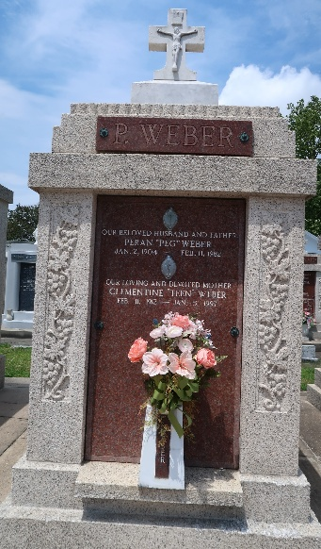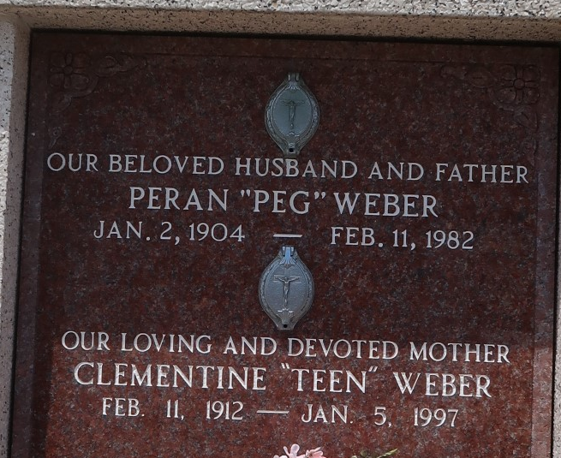
Photos by Mary Agnes Hammett

Peran (Peg) Weber on Thursday, February 11, 1982 at 11:30 p.m. , beloved husband of Clementine (Teen) Dupuy of Norco, LA, father of Mrs. Franklin Merlene St. Perrie of Laplace, LA, Mrs. Margaret Laurent, Mrs. Willie (Deanna) Maus of Reserve, LA, Marivain (Tojo) C. Weber of Norco, LA, Glynn J. Weber of Reserve, LA and Peran (Perrin) Weber, Jr. of Norco, LA.
Son of the late Eva Vicknair and Wilson Weber, brother of Mrs. Odelia Landry, Mrs. Beatrice Abate, Mrs. Lucette Weber, Mrs. Rose Freitas, Wilson (Coon) Weber, Jr., Clifford (Carut) Weber, James, Patrick Ray, Milton, Herbert and the late Lucien Weber, Sr., nephew of Mrs. Sedonia Madere, also survived by 13 grandchildren, age 78 years, a native on Montz, LA and a resident of Norco for the past 60 years.
Relatives and friends of the family also employees of Shell Manufacturing Complex are invited to attend the funeral. Services from the H. C. Aleander Funeral Home, 821 Fourth St., Norco, LA on Monday, February 15, 1982 at 10:00 a.m., followed by mass at Sacred Heart of Jesus Catholic Church.
Interment St. Peter Cemetery, Reserve, LA. Friends may call from 6:00 p.m. until 10:00 p.m. on Sunday, February 14, 1982 and from 8:00 a.m. until service time on Monday.
The Times-Picayune, New Orleans, Louisiana
February 14, 1982, p. 26

