Philip J. Weber
February 2, 1943 – December 8, 2012

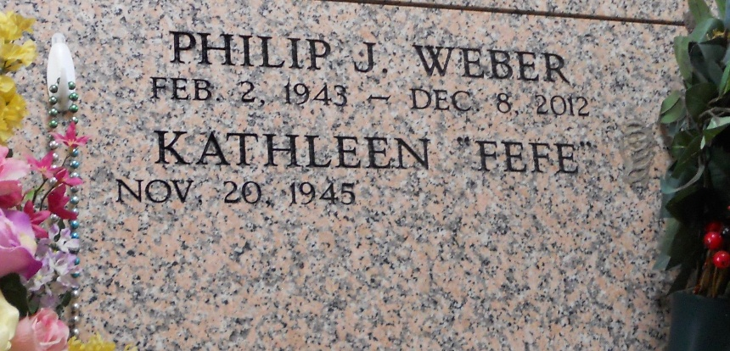
Photo by Team T-Lo

WEBER
Philip J. Weber passed away on Saturday December 8, 2012.

Beloved husband of Kathleen (FeFe) Cashio Weber. Son of the late Norman (Shot) and Doris Songy Weber. Brother of David, Melvin, Brian and Harvey Weber. Age 69. A native and resident of Reserve, LA.

Relatives and friends are invited to attend services. Visitation at St. Peter Catholic Church, Reserve, LA on Tuesday December 11, 2012 from 9:00 am to 12:00 pm, followed by Mass at 12:00 noon. Burial in St. Peter Cemetery. Arrangements by Millet-Guidry Funeral Home, LaPlace, LA.
The Times-Picayune, New Orleans, Louisiana
December 10-12, 2012

