Philogene J. Weber Sr.
February 19, 1884 – February 19, 1956

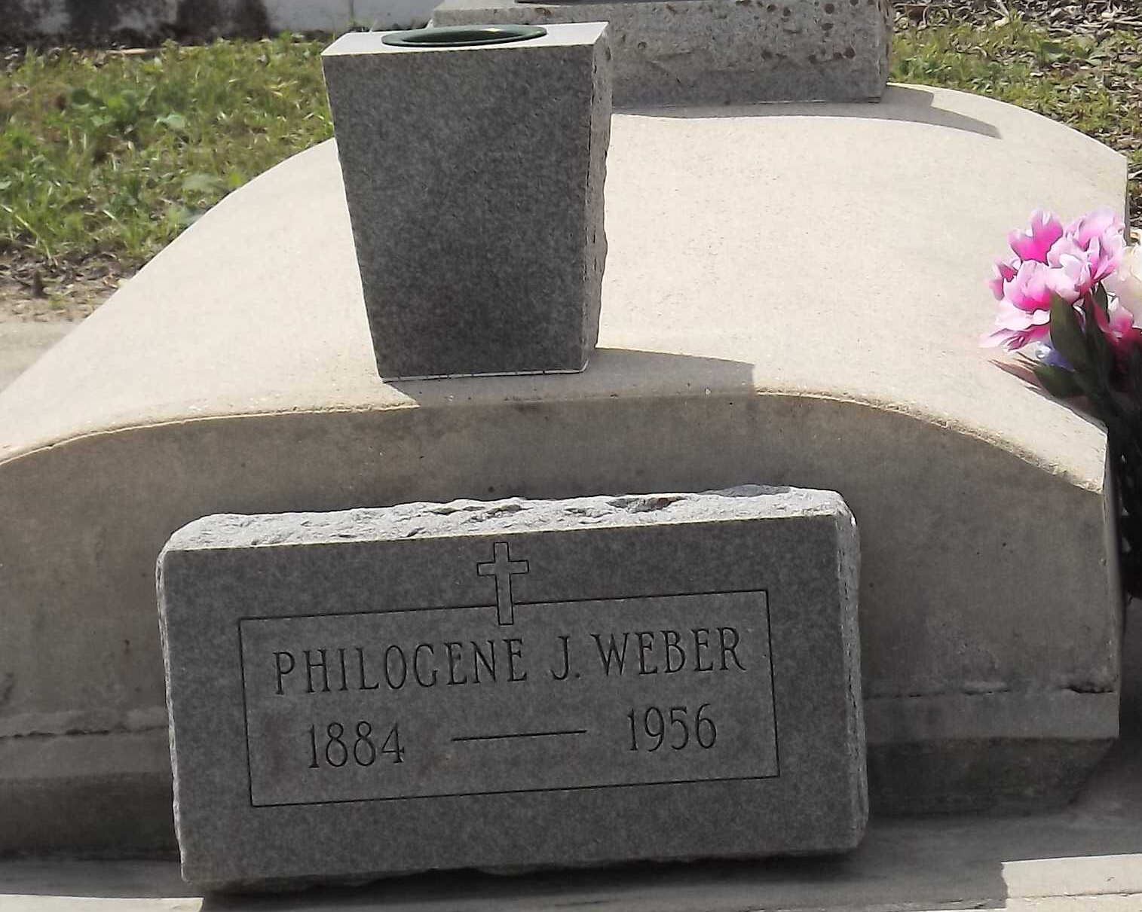
Photo by Mary Agnes Hammett

WEBER
Age 71 years, husband of the late Septima Cambre.

Father of Mrs. Hilda Cecile Keller and Mrs. Dennis Cambre of Laplace, Louisiana, Philogene Weber Jr, of New Orleans, Willie Weber of Oregon and Mrs. Charles Micheletti of Montana.

Services were Tuesday, 21 Feb 1956 at St, Joan of Arc Church, Laplace, with interment in St, Peter Cemetery, Reserve, Louisiana.
The Times-Picayune, New Orleans, Louisiana
February 21, 1956

