Shirley (John) Weber
June 2, 1923 – April 8, 2013

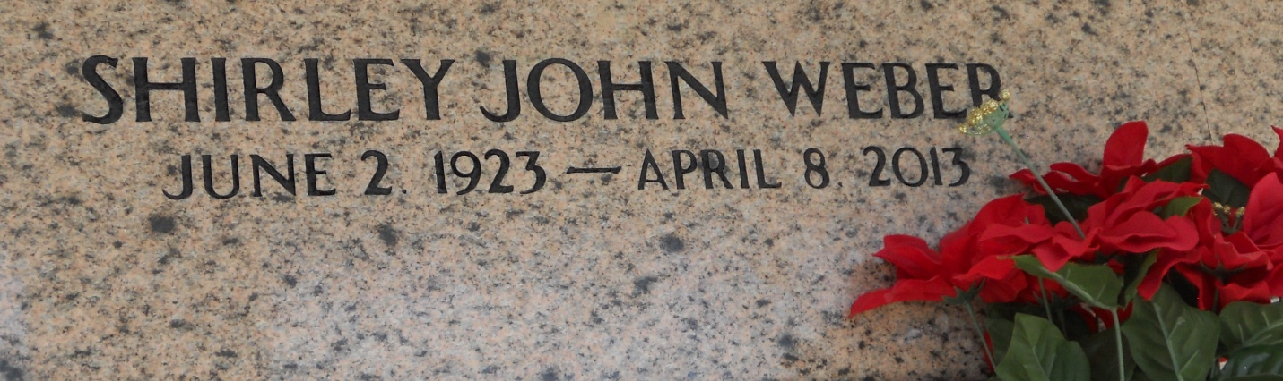
Photo by Team T-Lo

WEBER
A resident of Reserve, she died Monday, April 8, 2013, at age 89.

Visiting at Millet-Guidry Funeral Home, 2806 W. Airline Highway, LaPlace, on Friday, April 12, from 9 a.m. until service at 10 a.m. Burial in St. Peter Cemetery, Reserve. (985) 652-4208.
The Advocate, Baton Rouge, Louisiana
April 9-10, 2013

