Walter Benoit Weber
March 21, 1910 – May 14, 1966

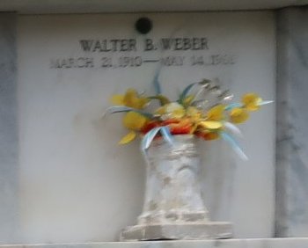

Funeral Rites For Walter J. Weber, 56, Are Held in Reserve

Final rites have been conducted for Walter J. Weber, 56 years old, who died May 14. The services were held from the Millet Funeral Home in Reserve, with religious services at St. Peter Church in Reserve and interment in the church cemetery.
Mr. Weber was preceded in death by his wife, who was the former Yvonne Stein. He was the father of Mrs. Joy Clement, Mrs. Sylvia Roussel and Gary Weber, all of Reserve.
He was the brother of Dewey, Benny and Roy Weber, Mrs. Sam Madere and Mrs. Daniel Cambre. He is survived also by 10 grandchildren.

L’Observateur, LaPlace, Louisiana
Thursday, May 19, 1966, p. 13

