Aaron C. Webre
January 7, 1981 – August 14, 2010

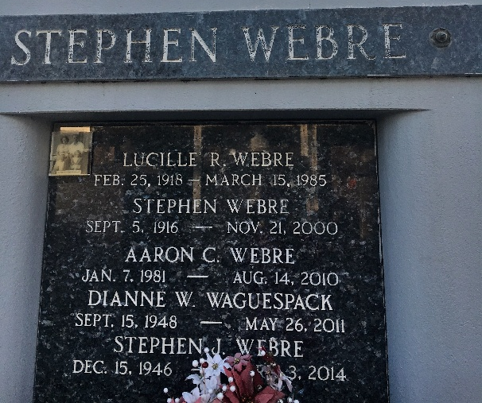
Photo by Team T-Lo

Aaron Webre passed away on Saturday, August 14, 2010.
Beloved husband of Julie Webre. Father of Nicole, Meghan and Jolene Webre. Son of Russell and Glenda Webre. Brother of Dawn Mathews, April Hebert, Karen Barry and Jonathan Webre. Age 29. A native and resident of Reserve, La.
Relatives and friends are invited to attend services. Visitation at Millet-Guidry Funeral Home, 2806 W. Airline Hwy., LaPlace, La., on Saturday, August 21, 2010 from 8:00 am to 10:00 am. Followed by Religious Services in the Funeral Home chapel at 10:00 am. Burial in St. Peter Cemetery, Reserve, La.
The Times-Picayune, New Orleans, Louisiana
August 20, 2010

