Stephen Webre
September 5, 1916 – November 21, 2000

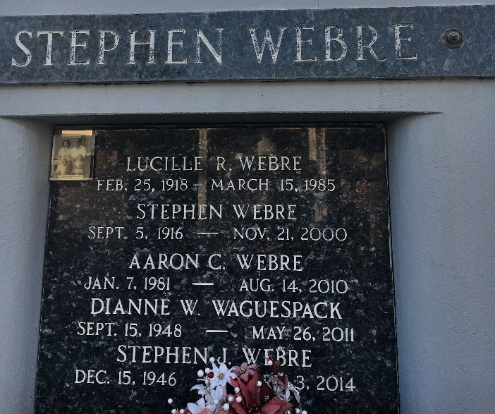
Photo by Team T-Lo

RESERVE - Stephen Webre, 84, a native of Edgard and resident of Reserve for 54 years, died Nov. 21.

He was the husband of the late Lucille Rousselle Webre and father of Dianne Waguespack and Stephen and Russell Webre. He was also the brother of Cecile Holmes, Rene and Theodore Webre and the late Isma Keller and Dudley Webre. He is also survived by 10 grandchildren and 12 great-grandchildren.

Services were held Nov. 24 at St. Peter Catholic Church, Reserve, with interment at the church cemetery.
L'Observateur, LaPlace, Louisiana
Friday, November 24, 2000

