Stephen J. Webre
December 15, 1946 – April 3, 2014

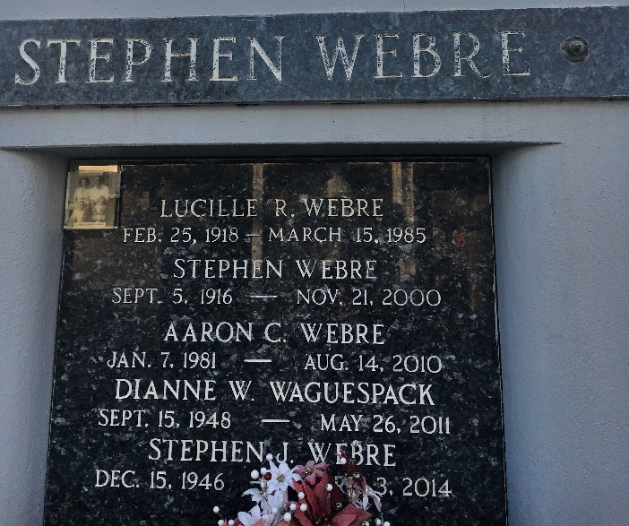
Photo by Team T-Lo

Stephen Webre died on Thursday April 3, 2014.
Father of Ryan Webre (Valerie), Amy Guillotte (Chris) and Kristy Cambre (Toby). Grandfather of Brandi, Erin, Erica, Laura and Nathan.
Son of the late Stephen and Lucille Rousselle Webre. Brother of Russell Webre and the late Dianne W. Waguespack. Age 67. A native of Reserve and resident of Gonzales.
Relatives and friends are invited to attend services. Visitation at Millet-Guidry Funeral Home, 2806 W. Airline Hwy., LaPlace, LA on Tuesday April 8, 2014 from 8:00am to 10:00am, followed by Religious Services in the Funeral Home Chapel at 10:00am. Burial in St. Peter Cemetery Reserve, LA.
In lieu of flowers donations preferred to the Mary Bird Perkins Foundation.
The New Orleans Advocate, Louisiana
Apr. 4 to Apr. 5, 2014

